FOB
Breakout System

A Personal Trading Manual

Compiled by: SIGMA trading

PRIVATE & CONFIDENTIAL

Intended for the personal use of the author and should not be distributed,
sold, or used for commercial purposes without explicit consent.

Acknowledgments

“ One must suffer from one of two pains, pain of discipline or pain of regrets “

It is what it is.
SIGMA Trading

All rights reserved. No part of this book/documents may be reproduced, distributed, or transmitted in any form or by any means, including photocopying, recording, or other electronic or mechanical methods, without the prior written permission of the author, except in the case of brief quotations embodied in critical reviews and certain other noncommercial uses permitted by copyright law.
This trading system is an adaptation of concepts from the Turtle Trading System, Bbreakout strategy, and a compilation of insights gained over years of learning from various mentors and experienced traders. It is intended for the personal use of the author and should not be distributed, sold, or used for commercial purposes without explicit consent.
For permission requests, contact the author at sigmatrading.ai@gmail.com.

Table of Contents
PHASE ONE 4
TERMS AND TERMINOLOGY 5
CMP 6
CMP - Current Market Price is the foundation of this overall system 7
CMP - Breakout 7
MTF 12
MTF - Multi Time Frame Confirmation *MTF linked closely with confirmation 13
MTF - Two types & Two types of Confirmation 13
MTF - High Risk - High Risk Confirmation 13
MTF - Example High Risk Confirmation 14
MTF - Example Low Risk Confirmation 14
MTF - Situation of High Risk & Low Risk Setups 15
MTF - Failed Breakout 16
VR 17
VR - Valid Retracement *MOST IMPORTANT IN OUR SOP 18
VR - Rules! 18
VR - Multi Timeframe 19
VR - Types and placements of VR 20
VR - Warning - Two types of VR 22
CF 23
CF - BO Structured & Non Structured Confirmation 24
CF - High Risk & Low Risk 24
CF - Placements 24
CF - Situation awareness 26
CF - & VR Relationships *3 am continue tomorrow at 2h.32m Phase 1 part 2 27
CF - & VR Sideways *Most common question asked to Sir B 2nd Video Phase 1 3:22:10 30
CMP - SOP 31
Special Note 31
DIRECTION & BIAS 32
Direction & Bias - Phase 1 part 2 video July 2024 3h:44m 33
Direction - Daily below 33
Bias - Weekly only 33
How to connect both Direction & Bias? 33
Direction + MTF = Same concept *Important Phase 1 part 2 video July 2024 4h:06m 34
BARRIER 35
Barrier - Sir B doesn't use barriers as entry points. He only use it for Take Profit Phase 1 part 2 video July 2024 4h:08m 36
Barrier - Can be used as a direction. Barrier after barrier 36
Barrier - 2 Rules 36
Barrier - Cheat Code Phase 1 part 2 video July 2024 4h:33m 38
RIDE THE TREND 39
Ride The Trend - Phase 2 video July 14 2024 38m 40
RTT - Purpose is for continuation setup *Setup Conti 40
Special Note 42
RTT - VR Fresh and Not Fresh *Setup Conti Layering 42
VR - Fresh 42
VR - Not Fresh 43
PHASE TWO 44
STORYLINE SEQUENCE 45
Storyline Sequence Phase 2 video July 14 2024 2h 38m 46
Why? 46
Explanation 46
What does it mean by control? 47
What does it mean by control? *This is to avoid missing that big movement 48
Most common problem? Phase 2 Video 2h 51m 48
Sequence Direction Phase 2 Video 3h 31m 49
Market Cycle Phase 2 Video 3h 59m 51
Cycle VR Breakout Phase 2 Video 4h 3m 33s 51
END OF THEORY 52
PHASE THREE 53
BIAS Phase 2 Sequence Video 4h 35m 54
Direction 55
Sequence Phase 2 Sequence Video 4h 40m 22s 56
Reversal signs Phase 2 Sequence Video 4h 45m 48s 58
Sequence Sell Phase 2 Sequence Video 4h 51m 0s 59
Sequence LTF Phase 2 Sequence Video 5h 04m 7s 60
Sequence VR Phase 2 Sequence Video 5h 34m 07s 62
Intraday OHLC - Open High Low Close Phase 2 Sequence Video 5h 44m 22s 63
Scalping Phase 2 Sequence Video 5h 58m 00s 66
Swing Phase 2 Sequence Video 6h 17m 48s 67
How to Back Test and do homework? Phase 2 Sequence Video 5h 37m 20s last 15 minutes 69
THE END 69

PHASE ONE

SEQUENCE

TERMS AND TERMINOLOGY
- VR = Valid Retracement
- CF = Confirmation
- CMP = Current Market Price
- CONTI = Continuation
- BO = Breakout
- FM = Full Margin
- MC = Margin Call
- TP = Take Profit
- SL = Stop Loss

Topic cover
MTF
Market Flow
Direction - Bias
Confirmation
How to ride a trend
Market cycle

CMP
Current Market Price

CMP - Current Market Price is the foundation of this overall system
- We don't look to the left on CMP, we focus on Current Market Price.
- CMP is important for drawing your zone. If you get it wrong your entry will be wrong, your TP will be wrong, your SL will be wrong.
- Do not ENTER on first BO as you must follow SOP FIRST.
- It can be used on ANY TIMEFRAME.

CMP - Breakout
Image 1.1
1st BO
2nd BO
3rd BO
Take latest BO, which is 3rd BO dont take no 2 or no 1

Why? Because it is the latest BO, No 1 & 2 has passed

CMP - Current Market Price break 3rd BO
*EXAMPLE CMP BO SELL

Image 1.2
1st BO
2nd BO
3rd BO
CMP - Current Market Price break 3rd BO

Take latest BO, which is 3rd BO dont take no 2 or no 1

Why? Because it is the latest BO, No 1 & 2 has passed
*EXAMPLE CMP BO BUY

Image 1.3
1st BO
2nd BO
3rd BO
CMP - Current Market Price break 3rd BO

Take latest BO, which is 3rd BO has made a new BO Buy

Why? 3rd BO has Break ABOVE, therefore it’s a new CMP BO BUY

Wait for candle to BREAK & CLOSE above, even 1 pip considered a Breakout
*EXAMPLE 2nd CMP BO BUY

Break
Image 1.4
1st BO
2nd BO
3rd BO
CMP - Current Market Price break 3rd BO

Take latest BO, which is 3rd BO has made a new BO Sell

Why? 3rd BO has Break BELOW, therefore it’s a new CMP BO SELL

Wait for candle to BREAK & CLOSE BELOW, even 1 pip considered a Breakout
*EXAMPLE 2nd CMP BO SELL

Break

Image 1.5

1st BO
2nd BO
3rd BO

Take latest CMP BO, which is 3rd BO has made a new BO Sell together with break below 3rd BO

Why? 3rd BO has Break BELOW together with 1st BO, therefore it’s a new CMP BO BUY

Wait for candle to BREAK & CLOSE BELOW, even 1 pip considered a Breakout

Shadow or Wick does not count!

*EXAMPLE 3rd CMP BO SELL

CMP - New Current Market Price BO
Break
Image 1.6
1st BO
2nd BO
3rd BO
*EXAMPLE 3rd CMP BO BUY

Take latest CMP BO, which is 3rd BO has made a new BO Buy together with break above 1st BO

Why? 3rd BO has Break ABOVE together with 1st BO, therefore it’s a new CMP BO BUY

Wait for candle to BREAK & CLOSE ABOVE, even 1 pip considered a Breakout
Shadow or Wick does not count!

CMP - New Current Market Price BO
Break

*EXAMPLE OF A CMP SITUATION

Image 1.7

PAY ATTENTION ON THIS!

Overall Direction is still a SELL as show on the graph

UNLESS price decides to break ABOVE Zone 1 then it becomes a BUY

Zone 2 supposed to be a continue sell which it could be. HOWEVER! You MUST follow CMP SOP which will be cover later

As shown on graph, price decides to break Zone 2 and go to Zone 1. Both Zones must follow CMP SOP. the BO buy on Zone 2 DOES NOT COUNT as a buy
Zone 1
Zone 2

Image 1.8
Quiz:

Where is your CMP???

Image 1.9

Quiz:

Where is your CMP???

Answer:
CMP is where the new BO *purple Circle

This red circle is not your CMP as it has not Break yet

*EXAMPLE OF A CMP SITUATION

Image 1.10

PAY ATTENTION ON THIS!

Price has Closed and made new CMP BO Buy. However, most likely there’s no clear SOP on Price to continue BUY. Price failed and reversed

This is why you must follow SOP!

Price also have to break Support to create new CMP BO Sell

This is all depends on which time frame and STORYLINE!
CMP BO Buy

CMP BO Sell

END OF CMP - Information was extracted from Bonker Video July 2024 Bonker Sequence Phase 1

MTF
Multi Timeframe

MTF - Multi Time Frame Confirmation *MTF linked closely with confirmation
- You will know Direction.
- You will know which Time Frame to use.
- You will know which VR relates to what Time Frame.
- You will know the confirmation on what Time Frame.

MTF - Two types & Two types of Confirmation
- High Risk.
- Low Risk.

MTF - High Risk - High Risk Confirmation
- As shown on image 2.1 below, Example, you used Monthly as trade set up, therefore high risk confirmation will be Daily. If you trade Daily TF you high risk confirmation would be H1. Notice that the system skipped Weekly and H4. Thus it's a High Risk Confirmation.

Image 2.1

Monthly
Weekly
Daily
H4
M30
H1
M15

M1
M5

MTF - Example High Risk Confirmation
- High risk because we skipped one time frame as we do not know how price will play out first therefore it's a High Risk Setups.
- If you decide to trade High Risk Setups, you will get a Discounted price, vice versa.

Image 2.2

Monthly
Daily
Weekly
H4
Daily
H1

High Risk Setups - You SKIPPED one Time Frame

MTF - Example Low Risk Confirmation
- High risk because we skipped one time frame as we do not know how price will play out first therefore it's a High Risk Setups.
- If you decide to trade Low Risk Setups, you will get a Premium price, vice versa.

Image 2.3

Monthly
Weekly
Weekly
Daily
Daily
H4

Low Risk Setups - You WAIT for one Time Frame Below

MTF - Situation of High Risk & Low Risk Setups

Image 2.4
PAY ATTENTION ON THIS!

Daily made BO Sell, H4 made BO Buy

Why High Risk?

You are trading against the trend

H1 had made BO Sell, AGAINST CMP H4 BO Buy

Therefore, H4 is a safer trade as in has made a confirmation which a clear SOP will be explain further
Daily setup BO Sell

H4 BO Buy

H1 Create BO Sell, High Risk
H4 BO Buy
CMP H4
BO Buy
Image 2.5
PAY ATTENTION ON THIS!

Daily BO Buy, H4 BO Sell as VR

Why High Risk?
You are trading against the trend

H1 had made BO Buy, AGAINST CMP H4 BO Sell Conti

Should you considered to enter High Risk H1 BO Buy, you can partial TP or Hold at nearest H4 CMP BO Sell
Continue loading your buy at H4 confirmation
Daily BO Buy

H4 BO Sell

H1 Create BO Buy High Risk
H4 BO Buy Low Risk

H4 BO Sell
H4 CMP BO Sell

*IF CF happens in the ZONE will take the High Risk and not repeat SOP because you might miss out on the movement, Again this is High Risk.
*IF CF happens below ZONE will take and follow SOP. Sometimes this could give you a good range of pips.

MTF - Failed Breakout

Image 2.6

Daily BO Sell Setup

PAY ATTENTION ON THIS!

Setup Daily Sell, H1 BO Buy

Is it a buy?

Not yet, as Daily MUST make a new BO buy

Follow your Time Frame Setups

Daily candle must failed it’s own setups
H4 candle must failed it’s own setups
H1 candle must failed it’s own setups
Daily

H1 BO Sell
Daily

H1 BO Sell

END OF MTF High Risk & Low Risk - Information was extracted from Bonker Video July 2024 Bonker Sequence Phase 1.End at 1h 40m.

VR
Valid Retracement
MOST IMPORTANT IN OUR SOP

VR - Valid Retracement *MOST IMPORTANT IN OUR SOP
- Previously this was a simple Breakout Pullback. The problem with using BO PB is that you will see prices PB multiple times.
- How to identify whether it's a Valid Retracement?

VR - Rules!
- You need one BO “oposite”, a breakout in a different direction. The best part is we know what TF we are on.
- Why? So we know what TF we are trading.
- Must look at one TF BELOW. Monthly will look at Weekly as VR in the opposite direction. Same goes with all TF
- DO NOT Skip TF.
- VR only happens ONCE!!!!!!!!

Image 3.1

M
W

W
D

D
H4

H4
H1

H1
M30

M5
M1

M15
M5

M30
M15

H1
M30
Valid Retracements
Image 3.2

Daily BO Sell
H4 VR, VR only once!
This is Conti not VR

VR - Multi Timeframe
- Relationship VR and MTF, VR is a point that validates a set up.
- If a BO happens with two Time Frames, double BO, which TF should you follow?
- You will have to look at which Time Frames that made VR first!
- Remember VR ONLY HAPPENS ONCE!

Image 3.3

PAY ATTENTION ON THIS!

Daily & H4 BO Buy.

Which TF should we follow?

Which ever TF that create a VR. VR will dictates which TF we will trade on

Follow your Time Frame Setups

In this case it’s H4 BO Buy because H1 has created VR

Scalping example.

H1,M30 & M15 BO buy.

M5 VR and create a new sell, which TF are you trading?

That will be M15 as, M5 have VR and break M15 support

Daily BO Buy
H4 BO Buy

H1 VR

H1 BO Buy
How to Scalp!

M30 BO Buy

M15 BO Buy

M5 VR
M15 BO Sell

VR - Types and placements of VR

- VR can happen in different areas
- VR must happen in a BO manner

Image 3.4

Types of VR

VR in zone *not the best
VR
VR

Image 3.5

VR Weekly Buy and it’s TF Setups What TF made VR first
*refer 2024 Bonker Sequence Phase 1 July 2h 38m

W Breakout
D
H4
H1
Weekly candle close up here, your right is a showcase of what is happening in a week
1.M30 BO Sell VR,
Set up H1
2.H1 CF Buy
3.H1 Bo Sell
4. H1 Bo Sell, Set up H4 now, Price break
5. No CF, price break, now it’s a D setup
6. H4 enter D zone with H4 CF
7.Price reject, maybe news
9. D has enter W zone, Now its a W set up. D create CF and price took off
8. Price break D zone and created VR for W
Image 3.6

VR Weekly Sell and it’s TF Setups What TF made VR first
*refer 2024 Bonker Sequence Phase 1 July 2h 42m

W Breakout
D
H4
H1
Weekly candle close down here, your right is a showcase of what is happening in a week
1.M30 VR Buy,
Set up H1
2.H1 CF Buy
7. New BO.
5. H4 Setup. If there's a CF you can trade it
4.H1 VR BO, Setup H4
8. Price BO VR Daily. W setup
3.Price reject
6.Price reject this zone to continue sell
9. Daily create CF Sell. Anchor lot / Full Margin. As we know this is a W set up

VR - Warning - Two types of VR
- Clean VR
- Messy VR - can be in a sideways, very messy
- Advisable not to trade “ride” VR. Entry with a CF in a zone is much better. Riding VR is High Risk unless the distance is far like Daily timeframe.

Image 3.7

PAY ATTENTION ON THIS!

Messy VR, Sideways VR

What should you do?

Wait for Low Risk CF for entry

Why?

VR in nature is High Risk!
Remember, VR main purpose is to tell you which TF to trade

When you buy here it will be high Risk.
You can avoid this when you understand about SEQUENCE

END OF VR Valid Retracement - Information was extracted from Bonker Video July 2024 Bonker Sequence Phase 1.End at 3h 10m.

CF
Confirmation

CF - BO Structured & Non Structured Confirmation

CF - High Risk & Low Risk
- Breakout CF normal - most common is a Conti Setups
- Breakout CF structured - most common for a Reversal Setups
- Which CF that Sir B always uses? *BO CF structured

Image 4.1

PAY ATTENTION ON THIS!

Two types of CF

Which one should you use?

Structured is always better!

Why?

It gives certainty in price will go to its direction

Breakout CF Normal
Breakout CF Structured
CF - confirmation

CF - confirmation structured
BO
VR
BO
VR

CF - Placements
- Breakout CF in the Zone is the best
- Breakout CF above Zone
- Breakout CF before Zone
- If CF failed, close your position first

Image 4.2

PAY ATTENTION ON THIS!

CF in the zone

Which one should you use?

Safe

CF in the zone
CF - in the zone
BO sell
VR buy
CF sell

PAY ATTENTION ON THIS!

CF in the zone

Which one should you use?

Should try and avoid this
But if price break above and below the zone it would be great

CF above zone
CF - above the zone
BO sell
VR buy
CF sell

PAY ATTENTION ON THIS!

CF below the zone

Which one should you use?

This zone can be use as well

CF before zone
CF - below the zone
BO sell
VR buy
CF sell

CF - Situation awareness
- VR, CF, Pullback
- Shadow can be count as well
- If CF failed, close your position first
- CF is an essential part of Storyline
- CF stops before the zone sometimes because of barriers. There's cases where there's no barrier but price still make cf before zone

Image 4.3

PAY ATTENTION ON THIS!

Once there’s CF, repeat SOP

Why?

Further minimize RISK!

Take note

If the CF zone is 20 pips, it’s not worth it to repeat SOP. if 30 pips above repeat SOP
Repeat SOP again and again
There's CF that will just move, there’s ways to counter it which will be explained later
CF that need and doesn’t need to repeat SOP will be explain as well

CF Situation
CF H1
BO
VR M30
CF M15
PB M5
REPEAT cycle of SOP again and again so easy to understand

CF - & VR Relationships *3 am continue tomorrow at 2h.32m Phase 1 part 2
- Have several situations
- Failed set up that will always happen
- Backtest on Daily BO, follow images below, this is to understand STORYLINE!!!

Image 4.4

PAY ATTENTION ON THIS!

D BO sell, H4 VR, H1 CF. Do not enter SELL at CF zone when price comes back from VR Zone

Why?

RISK! Price has reject zone H4 VR indicating price will further break H1 CF zone.

Take note

This always happen as you will think its a valid CF to continue sell
It is because price failed to break VR Zone

CF & VR SELL Situation 1
1.CF H1
D BO Sell
H4 VR Buy Zone
2. CF Price ends in H4 VR zone. Failed to break VR Zone
3. Do not entry sell here
Image 4.5

PAY ATTENTION ON THIS!

D BO sell, H4 VR, H1 High Risk CF. You can take sell as price has enter D Sell zone, but have to TP at VR Zone

Why?

VR ZONE H4. VR is most important in our SOP

Take note

Price FAILED to break H4 VR Zone
Do not sell.
Follow SOP and wait for new CF

CF & VR SELL Situation 2
1.CF H1 High Risk CF
D BO Sell
H4 VR Buy Zone
3. CF Price ends in H4 VR zone. Failed to break VR Zone
2. VR Zone is strong. Have to wait for new BO
4. DO NOT SELL

Image 4.6

PAY ATTENTION ON THIS!

D BO sell, H4 VR, H1 CF. Price BO failed CF and best entry point

Why?

Price rejected VR H4, Break ABOVE CF HR H1 and PB

Take note

You MUST TP in Daily zone
Pay attention on H4 VR Zone

CF & VR BUY Situation 1
1.CF H1
D BO Sell
H4 VR Buy Zone
2. CF Price ends in H4 VR zone. Failed to break VR Zone
3. Best place SCALP to BUY
4.TP Here

Image 4.7

PAY ATTENTION ON THIS!

This could be Point of Reversal. Now start new cycle

Why?

Price rejected VR H4, Break ABOVE CF HR H1 and PB

Take note

You MUST see WHERE is this happening!
Location is important as you will see this as a starting point of a REVERSAL

CF & VR BUY Situation 2
1.CF H1
D BO Sell
H4 VR Buy Zone
2. CF Price ends in H4 VR zone. Failed to break VR Zone
3. Best place to BUY
4.New BO
Image 4.8

PAY ATTENTION ON THIS!

Price Break VR ZONE. The best time to entry. Reject VR Zone, create structure and break VR Zone

Why?

VR as important ZONE! IF this happen in H4 best point to FULL MARGIN

Take note

STRONG BREAK AND CLOSE
Not small break VR zone
You don't have to wait at H1 CF zone
Follow your TF to which make and break VR Zone
Sir B always said this happen on H1 below

CF & VR BEST SET UP Situation 1 *Break LINE CHART
1.CF H1
D BO Sell
H4 VR Buy Zone
2. Price finally break VR Zone. Remember it has to be H4 that break the zone
3. Best place to SELL
Image 4.9

PAY ATTENTION ON THIS!

Price Break VR ZONE. The best time to entry. Reject VR Zone, create structure and break VR Zone

Why?

VR as important ZONE! IF this happen in H4 best point to FULL MARGIN

Take note

STRONG BREAK AND CLOSE
Not small break VR zone
You don't have to wait at H1 CF zone
Follow your TF to which make and break VR Zone
this happen on H1 below

CF & VR BEST SET UP Situation 2 *BREAK LINE CHART
1.CF H1
D BO Sell
H4 VR Buy Zone
2. Price finally break VR Zone. Remember it has to be H4 that break the zone
3. Best place to SELL

CF - & VR Sideways *Most common question asked 2nd Video Phase 1 3:22:10
- “If price break our CF?”
- Answer : Wait for new CF

Image 4.10

PAY ATTENTION ON THIS!

Wait for 2nd CF to happen

Why?

VR ZONE H4. 2nd CF is best CF in this CASE

Take note

New CF doesn’t have to be in line it can be a new CF
Monitor price to break H4 VR Zone

CF & VR SELL Situation CONTINUATION
3.WAIT for 2nd
CF to entry
D BO Sell
H4 VR Buy Zone
4. Confirm a new BO
1. VR Zone is strong. Have to wait for new BO
2. DO NOT SELL FIRST

Image 4.11

2nd CF Buy here in VR Zone

PAY ATTENTION ON THIS!

Wait for 2nd CF to happen
CF does not have to be side by side

Why?

Price sideways

Take note

New CF doesn’t have to be in line it can be a new CF
Follow main direction
Don’t get caught

CF & VR BUY Situation SIDEWAYS
BO
VR
1st CF Don’t Buy here

Image 4.12

Purpose - of a Breakout

Repeat SOP with CF in Zone

PAY ATTENTION ON THIS!

Wait for 2nd CF to happen
CF does not have to be side by side

Why?

Price sideways

Take note

New CF doesn’t have to be in line it can be a new CF
Follow main direction
Don’t get caught Selling

CF & VR BUY Situation SIDEWAYS
BO
VR
Do not SELL!!!
Buy
- A breakout with a FOBr system must follow its SOP. A breakout has a meaning of its own. VR BO is a sign that price will reverse with a CF BO from its CMP BO.BO - VR - CF.
- Each breakout signifies whether the trade is a reversal, continuation or retracement or cf.
- Double Breakout considered as Continuation. *ex - Daily BO Sell, H4 also BO Sell.
- Every BO that happens just checks one TF higher to see what the price is doing.

CMP - SOP
- Breakout - Valid Retracement - Confirmation
- BO - VR - CF
- H4 BO Sell, H1 VR, H1 CF low risk, M30 CF high risk - Refer PHASE ONE

Special Note
"Choose any of the setups mentioned above for your entry. This will help you understand your strengths. These setups are optimal depending on your trading style. Some traders use these simple setups to trade large positions, like 100 lots or 30 lots. Keep in mind that these traders do not trade all the time."

END OF CF Confirmation - Information was extracted from Bonker Video July 2024 Bonker Sequence Phase 1 Part 2 video.End at 3h 26m.

DIRECTION & BIAS

Direction & Bias - Phase 1 part 2 video July 2024 3h:44m

Direction - Daily below
- Show the direction in which the price is moving.
- Buy or Sell on any breakout.
- Prioritize Daily

Bias - Weekly only
- A helicopter view of overall direction. Main direction.
- The Sigma System analyzes exclusively on the Weekly time frame only.
- The Weekly time frame helps us understand what is happening on the Monthly time frame and provides insights into the Daily time frame and those below.

How to connect both Direction & Bias?
- If you understand BIAS you will trade with ease.
- BIAS buy, we will prioritize buy, as long as Daily keep on Breakout Buy.
- If you want to Sell you have to wait Daily to make a Sell.
- That Sell is temporary, at any time that Sell can become Buy.
- Vice versa on all above.
- Bias plus sequence will be powerful!!!
- If Weekly is near and entering the Weekly Barrier be careful!!!

Image 5.1

PAY ATTENTION ON THIS!

BIAS buy, Buy until Daily create BO Sell

Why?

Bias is stronger

Take note

Sell is temporary
Bias is on buy so keep on buying

Direction + Bias Connection
W BO
D BO
D BO Sell
D BO
D BO
D BO
D BO
D BO Sell
D BO Sell
D BO Sell
D BO

Direction + MTF = Same concept *Important Phase 1 part 2 video July 2024 4h:06m
- Each TF will look for another TF
- From m1 to m5 to m15 to m30 and so on

Image 5.1

PAY ATTENTION ON THIS!

Generally each BO will look for its pair

Why?

It’s the closest TF to which price made a BO

Take note

Things will be clearer in Sequence Video
Refer to VR chapter if you confuse

Direction + Multi Time Frame
BO M1 - M5 - M15 - M30 - H1 - H4 - D - W - M
BO D sell
H4 create a VR. H4 will look for Daily
D high risk CF is H1. H1 CF will look for H4
H4 VR zone, if price break it will become H4 setups. H4 will look for? Daily

END OF Direction & Bias - Information was extracted from Bonker Video July 2024 Bonker Sequence Phase 1 Part 2 video.End at 4h:08m.

BARRIER

Barrier - We don’t use barriers as entry points. We only use it for Take Profit Phase 1 part 2 video July 2024 4h:08m

Barrier - Can be used as a direction. Barrier after barrier
- Entering at a barrier is not advisable due to the high likelihood of price rejections. Using the current market price (SEQUENCE) for entry is a much safer approach.

Barrier - 2 Rules
- Same Time Frame barrier - Daily BO to Daily Barrier
- One Time Frame below the barrier.
- Bonus - Overlap Barrier.

Image 6.1

PAY ATTENTION ON THIS!

Rules of Barrier. D to D and so on

Why?

It will look for it’s own TF first

Take note

Barrier to Barrier

Barrier - Same Time Frame
BO
D Sell
D will look for D First
BO
D Buy
Image 6.2

PAY ATTENTION ON THIS!

Lower Time Frame will look for barrier. Clearing barrier by barrier on LTF. 1st barrier must break!!!

Why?

As higher TF looking for its own TF

Take note

Price POTENTIAL to look for its barrier
FM CF in zone PBO. Why because its Daily PBO. Big TF
Follow Sequence SOP

Barrier - One Time Frame Below
BO
D Sell
BO
D Buy
LTF
Barrier
Before VR happen
PB Buy with CF
for FM
CF Structured for FM
1st Barrier MUST break!
Image 6.3

PAY ATTENTION ON THIS!

Becareful when barrier rejection with a shadow

Why?

Price make a new BO Sell and break VR

Take note

Rejection does not mean it rejects.
Simply wait for a new breakout
Hence, why Sir B don't trade barrier buy without a CF

Barrier - One Time Frame Below
BO
Sell
BO
D Buy
LTF
Barrier
Before VR happen
Barrier Rejection with just Shadow
VR zone must break

DO NOT Buy! Or Sell!
Image 6.4

PAY ATTENTION ON THIS!

Overlap barrier above are not to use as an entry

Why?

That barrier has already break

Take note

Therefore wait for new CMP BO or VR zone BO
Barrier - Overlap
BO
Sell
BO
D Buy
LTF
Barrier
Before VR happen
Just wait for this VR to break and entry on CF when price come back into VR BO Zone
DO NOT Sell when this barrier has break. It's considered as overlap
Overlap BO zone

Barrier - Cheat Code Phase 1 part 2 video July 2024 4h:33m
- Hinting of a reversal signal.
- When price sideways in a barrier zone. Most likely it will reverse
- Create a new BO and BO again towards the opposite direction.
- The opposite BO did not break barrier support or resistance.
- This usually happens in the same TF and with a VR
- Use M30 for GOLD
Image 6.5

PAY ATTENTION ON THIS!

Price sideways at barrier. Wait for a BO

Why?

New BO to a new direction as price failed to break barrier

Take note

Once there is a new BO from the sideways just follow that BO
If price break sideways and break barrier. Then it will go towards the direction of barrier BO
Barrier - Sideways
BO
Sell
BO
D Buy
LTF
Barrier
Before VR happen
Price Sideways at a barrier and make a new BO. So just follow the new BO
Image 6.6

PAY ATTENTION ON THIS!

Price make early BO sell before Barrier. Entry sell at Barrier Resistance

Why?

That barrier has not break

Take note

M30 the best for the reversal barrier
Barrier - Cheat Code
1st Barrier
2nd Barrier
BO Sell
BO Buy
Price failed to BO barrier

RIDE THE TREND

Ride The Trend - Phase 2 video July 14 2024 38m

RTT - Purpose is for continuation setup *Setup Conti
- When to use it?
- Safest way is to wait for one BO in Bigger TF. If you want to Conti on H4 you have to look at Daily BO first.
- H4 BO sell, keep on selling until there's a new H4 BO buy. In this case, turn to H1 and look for a multiple H1 BO sell because H4 Is still selling.

Image 7.1

PAY ATTENTION ON THIS!

It’s a conti setup on H1

Why?

H4 BO sell, H1 keep making bo sell

Take note

Watch out for barrier
You can TP at barrier
Once at barrier you monitor first

RTT - Conti Sell

H4 BO Sell
H1 Conti Sell
Image 7.2

PAY ATTENTION ON THIS!

D BO Sell with H4 conti

Why?

H4 keep on BO Sell

Take note

Watch out for barrier
You can TP at barrier
Once at barrier you monitor first
Keep conti as long as there is no VR BO

RTT - Conti Sell
D BO buy
D BO buy
D BO sell
H4 BO sell
Relax first here
Barrier break

Image 7.3

PAY ATTENTION ON THIS!

VR straight to BO zone for conti without CF

Why?

Same concept BO VR and stuck in barrier- its the same concept
VR happen without a structure

Take note

If you're not confident can wait for CF or HR CF

RTT - Conti Buy that does not need CF
H4 BO buy
H1 VR
Usually price will touch and go without CF
If you want to enter look high risk CF M30 for buy
Image 7.4

PAY ATTENTION ON THIS!

We follow CMP SOP. Thus conti sell on left drawing

Why?

Conti because of BO sell normal compared to with structure that have potential to break below

Take note

No matter huge the movement, just follow CMP SOP. BO-VR-CF

RTT - Conti
BO Normal NO structure

BO with
structure
False big movement,
sell off etc

Video paused at 1:09:44

Special Note
“ When you truly understand direction and storyline, VR and Barrier will be an easy walk “
“ Sir B students make millions on riding Setup Conti “

RTT - VR Fresh and Not Fresh *Setup Conti Layering
Phase 2 video July 14 2024 1h 53m

VR - Fresh
- After a breakout price straight go into origin zone BO.
- No retracement into VR Zone
- “WAJIB TP bila entry CF untuk masuk zone VRF”
- Wait for 2nd CF for layering

Image 7.5

PAY ATTENTION ON THIS!

It's a VR Fresh as price has not retracted and closed back into VR Zone. 1st entry MUST TP in VR zone.

Why?

VR zone is fresh and most likely will create a CF for sell first

Take note

You must wait for a new CF to enter. If price create a new CF you can start layering/stacking your entries

RTT - FOB FRESH
BO
VR normal
No retracement in VR zone after BO
CF Entry 1
CF Entry 2
Entry 1 TP here
Layer
VR zone

VR - Not Fresh
- After a breakout price retracement “close” inside VR Zone. Shadow does not count.
- This particular VRNF is considered as VR structured.
- Price will go back to

Image 7.6

PAY ATTENTION ON THIS!

Difference between fresh or not fresh is that no retracement on VR zone. Therefore you can ride the wave

Why?

VR zone is no longer Fresh therefore you can hold

Take note

You must wait for a new CF to enter. If price create a new CF you can start layering/stacking your entries

RTT - VR NON FRESH
BO
VR Structured
Retracement in VR zone after BO
CF Entry
Ride the trend
Layer
VR zone

END OF PHASE ONE

PHASE TWO

STORYLINE SEQUENCE

“ Once you understand storyline
you can enter without CF
given its in the right place “

STORYLINE SEQUENCE

Storyline Sequence Phase 2 video July 14 2024 2h 38m

Why?
- Understanding the storyline sequence helps you know how to use different timeframes effectively and decide where to take profit and to hold your trades. By mastering Phase 1 and combining it with Phase 2, your analysis becomes much clearer, allowing you to identify your current position in the market more easily.

Explanation
- Every market movement, whether it's a price break of structure or a significant surge, is influenced by TRADE CONTROL.
- These movements are linked to Multiple Time Frames (MTFs), highlighting which time frame is controlling the market at any given moment.

Image 2.1.1

Sequence
PBO
Fob
CF
PBO
Fob
Samples structure that always happen, price move without a pullback, and Cf Happen in PBO

What does it mean by control?
- One TF lower will control one TF higher.
- In Daily BO there will be H4 to control the movement of daily. Therefore, H4 is a trade control.
- REMEMBER, Price moves Up and Down. So H4 will make a BO sell and a reverse BO buy to continue to its destination.

Image 2.1.2

Sequence
M1 - M5 - M15 - M30 - H1 - H4 - D - W
Lower Timeframe control the bigger Timeframe
D
H4
H4
H4
H4
H4
H4
H4
H4

Daily

H4

H1

What does it mean by control? *This is to avoid missing that big movement
- It's basically a BO-VR-CF.
- When you combine this with SOP you know where to properly buy and sell
- Lower TF completes HTF with a condition that a Higher TF making a BO

Most common problem? Phase 2 Video 2h 51m
- “Missing the movement” - When a big TF make a BO and you waiting for CMP SOP to repeat
- This will lead you too waiting for “price that is not coming back”
- Catch whichever LTF that makes a VR not M1 ! take M5 and above
- WITH SEQUENCE you will know which setups NOT TO TRADE
- Sequence basically finding VR on lower TF when HTF candle trending

Image 2.1.4

PAY ATTENTION ON THIS!

After CF breakout and price rally. Look for M30 to entry.

Why?

M30 moves H1, Therefore you have to trade M30 CMP SOP

Take note

If there’s no sign on M30 bo with m15 VR then look for M15 BO, M5 VR - this is Sequence
From these sequence we KNOW WHICH SET UP That you don’t have to enter

Sequence - “Waiting for price that does not come back”
H4 BO
VR Structured
H1 price trending.
Who move H1???
M30
H1 VR
H1 CF

Sequence Direction Phase 2 Video 3h 31m
- It has a high potential to show where we should TP
- Distance of the TP so we can maximize our profits
- Sequence between Time Frames. When you have MTF Breakouts, H4,M30,H1 collectively, price will make strong move

Image 2.1.3

Image 2.1.4

PAY ATTENTION ON THIS!

TP at Weekly. Daily looking for Weekly.

Why?

H4 Trade control Daily

Take note

When you trade H4. follow CMP SOP, H1 VR&CF LR, HR M30 CF
From these sequence we KNOW WHICH SET UP That you don’t have to enter

Sequence Direction - “Swing”
H4 BO
Weekly Bo Sell
H4 Tp at Weekly
Daily VR

PAY ATTENTION ON THIS!

Time frame in a time frame

Why?

Lower Time Frame control one higher time frame
LTF has completed the sequence

Take note

These breakouts happen with multiple breakout with 3 different time frames ON THE SAME DIRECTION !!!- “Setaman”
Concurrent confirmation

Sequence Direction - “Setaman” Multi Breakout at the same time
Daily Bo Buy
Lower Time frame SOP

Image 2.1.5

PAY ATTENTION ON THIS!

Counter buy on H1 VR

Why?

Higher Sequence TF still a buy

Take note

Watch out resistance at H4 BO sell
VR to VR
Important that Higher TF Sequence not turning direction

Sequence Counter - “False Breakout”
Multi Breakout at the same time Phase 2 Video 3h 52m
H4 Buy Sequence Buy
H4 BO Sell
H1 VR for counter buy. Major TF still in buy sequence
Partial TP
Image 2.1.6

PAY ATTENTION ON THIS!

Scalp on VR H1

Why?

VR to VR trade

Take note

Important that Higher TF Sequence not turning direction
High risk CF is a VR to VR trade. VR trade is risky in nature
Have to be quick and full attention
Sequence scalp need skills

Sequence Scalping
Daily BO Sequence Buy
High Risk CF buy
H4 VR Sell
H1 VR Buy. Scalp buy here
H1 VR Buy. TP Scalp here
H1 VR Buy for this sell
Low Risk CF buy

Market Cycle Phase 2 Video 3h 59m
- It's a repetition of CMP BO VR CF - that is a cycle
- Price have to break VR to repeat its cycle and become cycle by cycle
- As we trade CMP we repeat CMP SOP

Image 2.1.7

Cycle Sequence
Just repeat CMP SOP. That is CYCLE
New Cycle
CMP SOP
CMP SOP
BO-VR-CF

Cycle VR Breakout Phase 2 Video 4h 3m 33s
- When price BO VR and Pullback DO NOT ENTER. MUS WAIT FOR NEW CYCLE BO

Image 2.1.8

Cycle VR Breakout
Enter at NEW BO not at BO VR. refer back to RTT VR chapter and VR chapter
DON’T Enter on PB. VR is high risk
VR
Enter on New BO

END OF THEORY

PHASE THREE

MT5 CHARTS

BIAS Phase 2 Sequence Video 4h 35m
- Only use Weekly Time Frame
- Look for weekly candle close
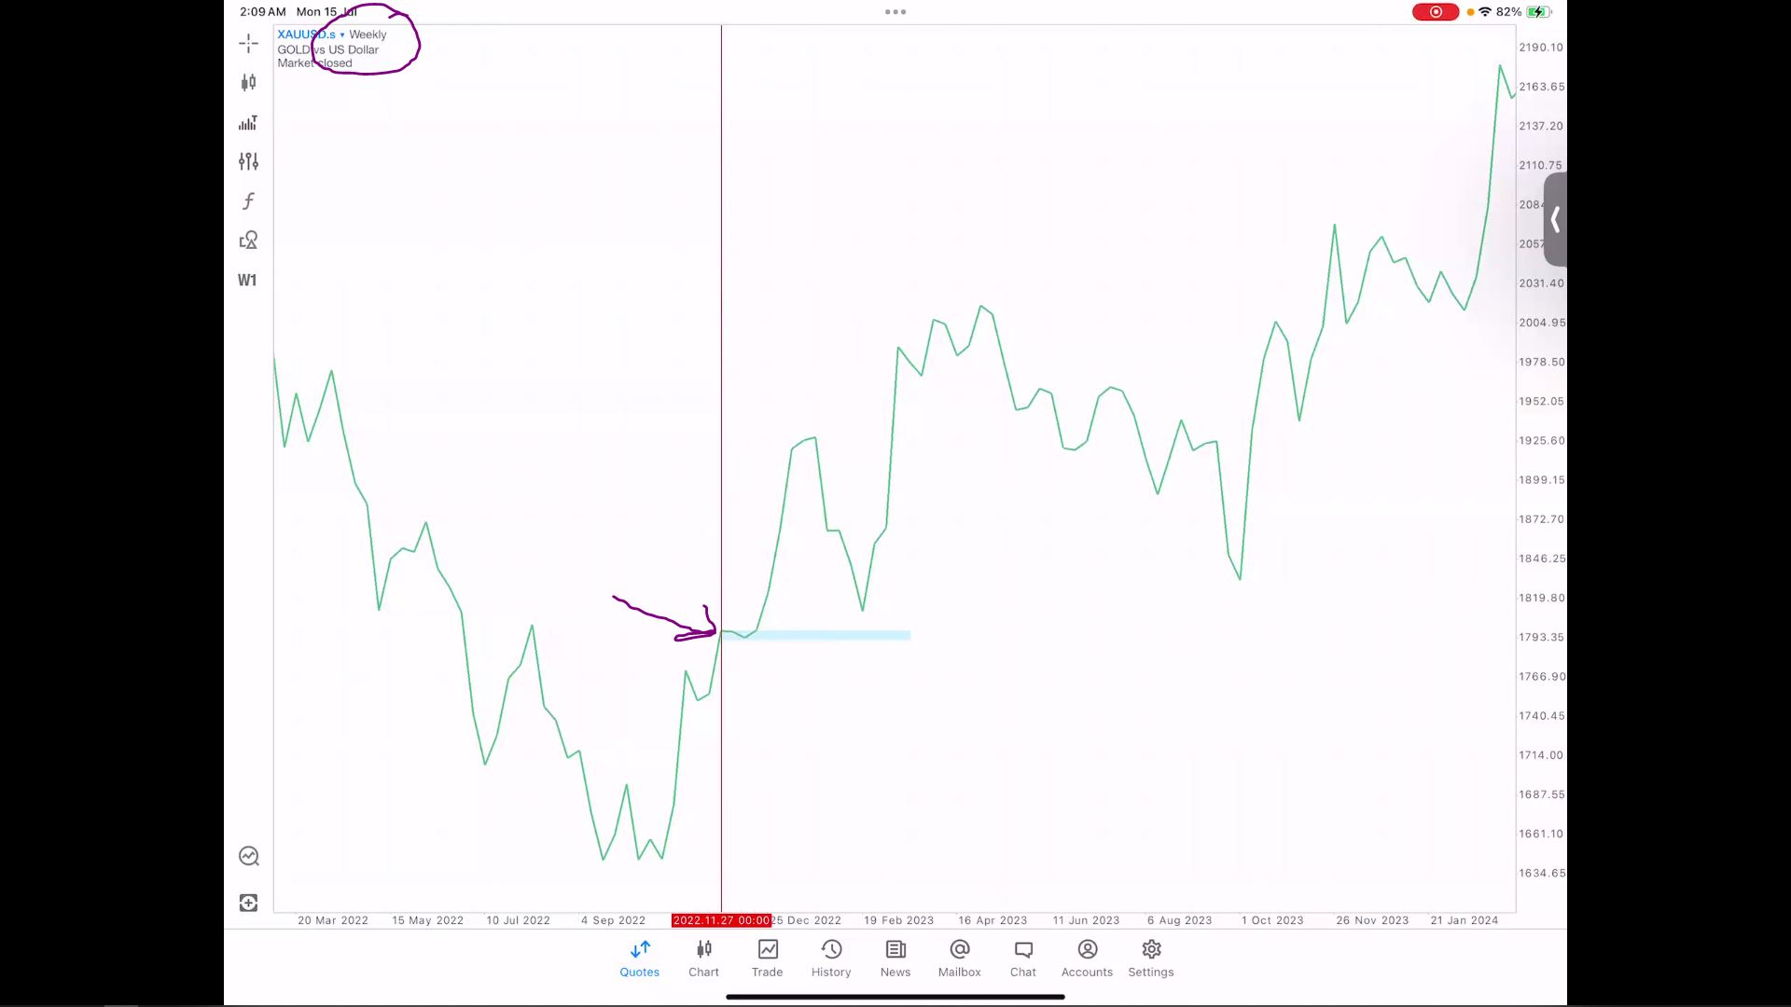
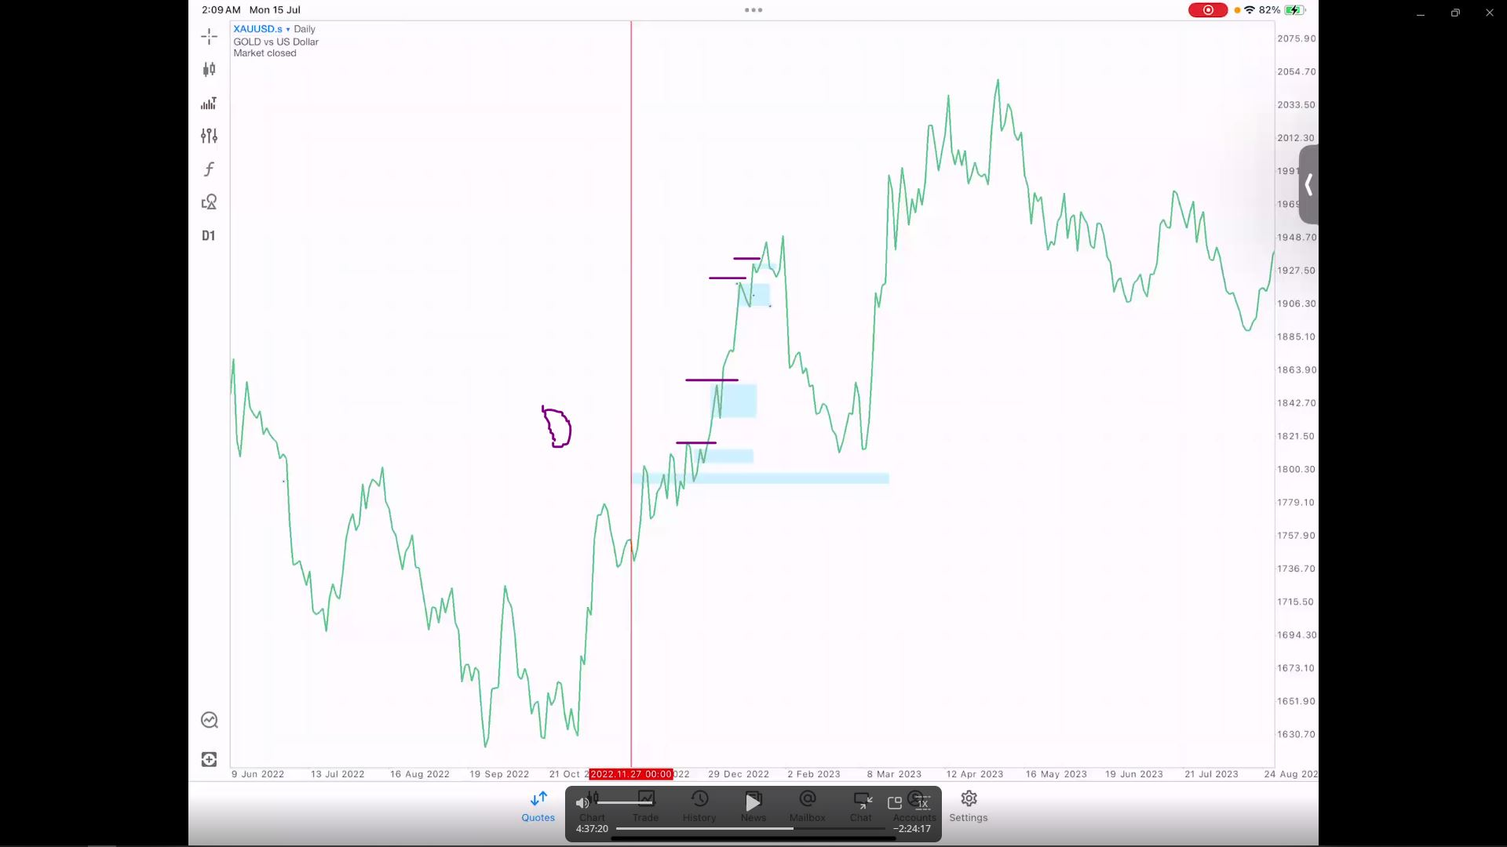

Direction
- Check where the daily candle closed.
- Identify the direction of closing price Daily candle. Bias buy, Direction buy. Direction sell you sell.
- Where's the sequence? It will be H4. Repeat SOP CMP. H4 control Daily.

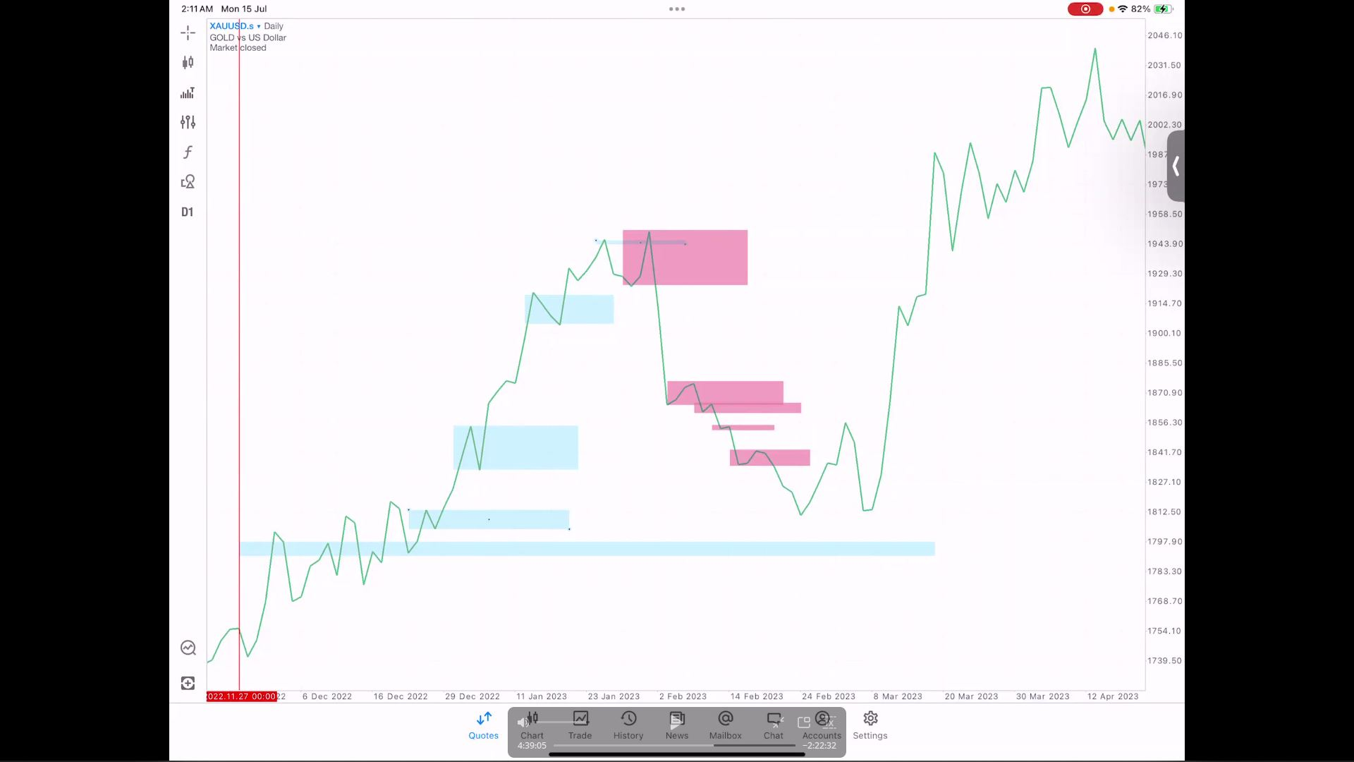
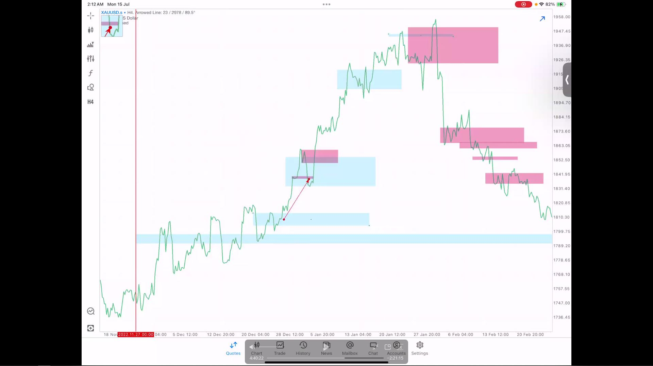

Sequence Phase 2 Sequence Video 4h 40m 22s
- H4 created BO VR with BO Sell. However Bias W and DIrection D is still a buy.
- This is why it’s important for you to understand SOP and Sequence.
- H4 created VR WITHOUT STRUCTURE. Therefore, prioritize BUY and not Sell
- Bias Weekly buy - Direction Daily Buy - H4 VR Sell VR is for continuation Daily BO Buy. Simple
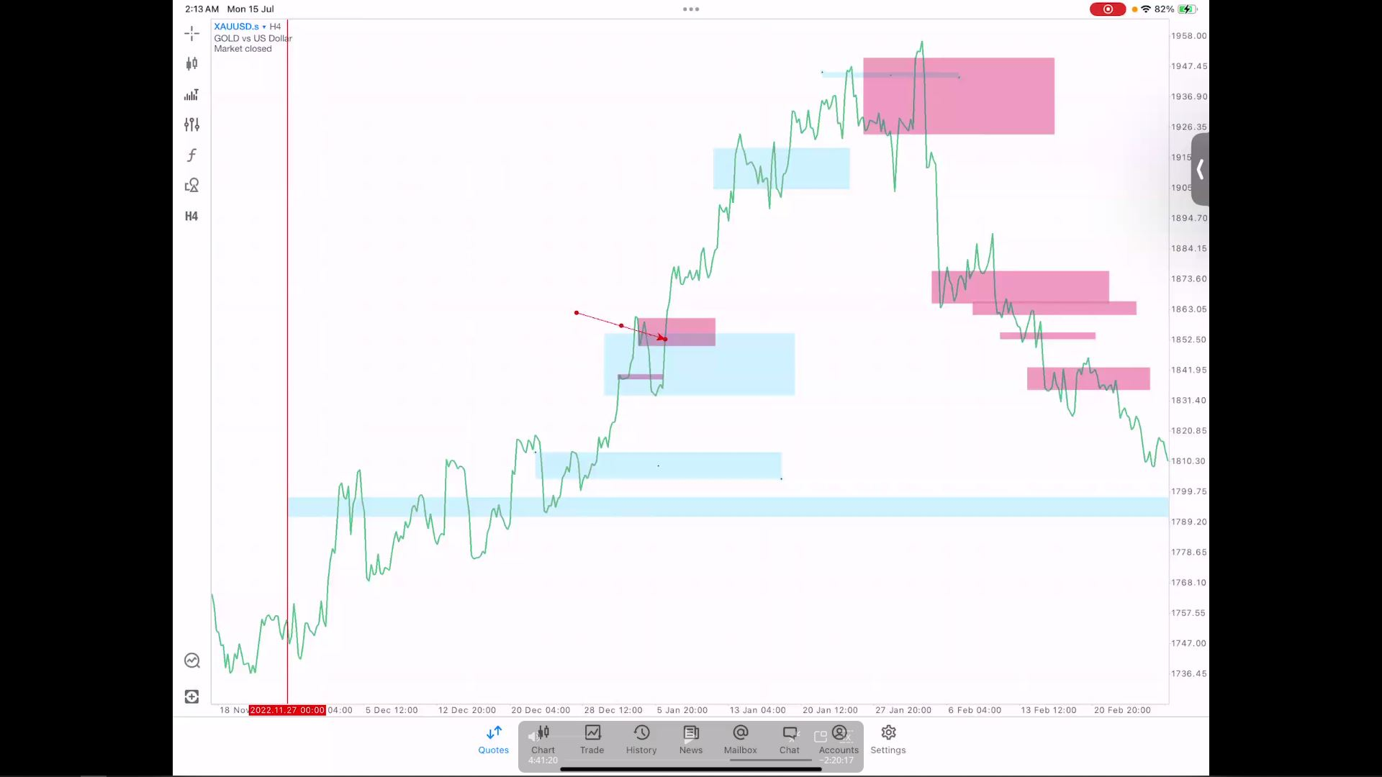
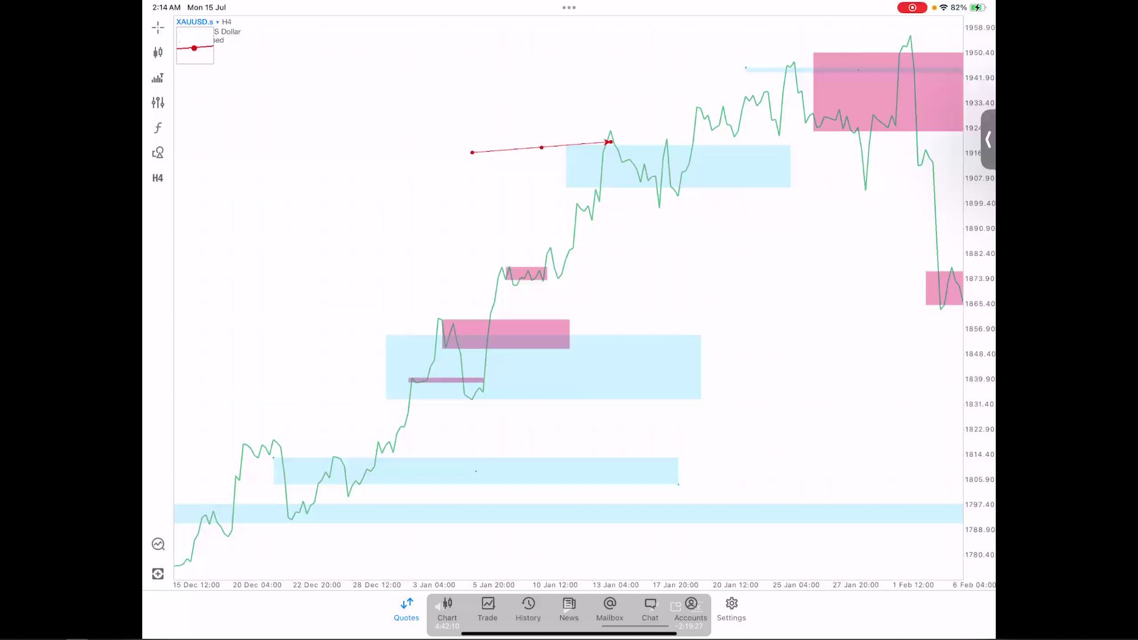
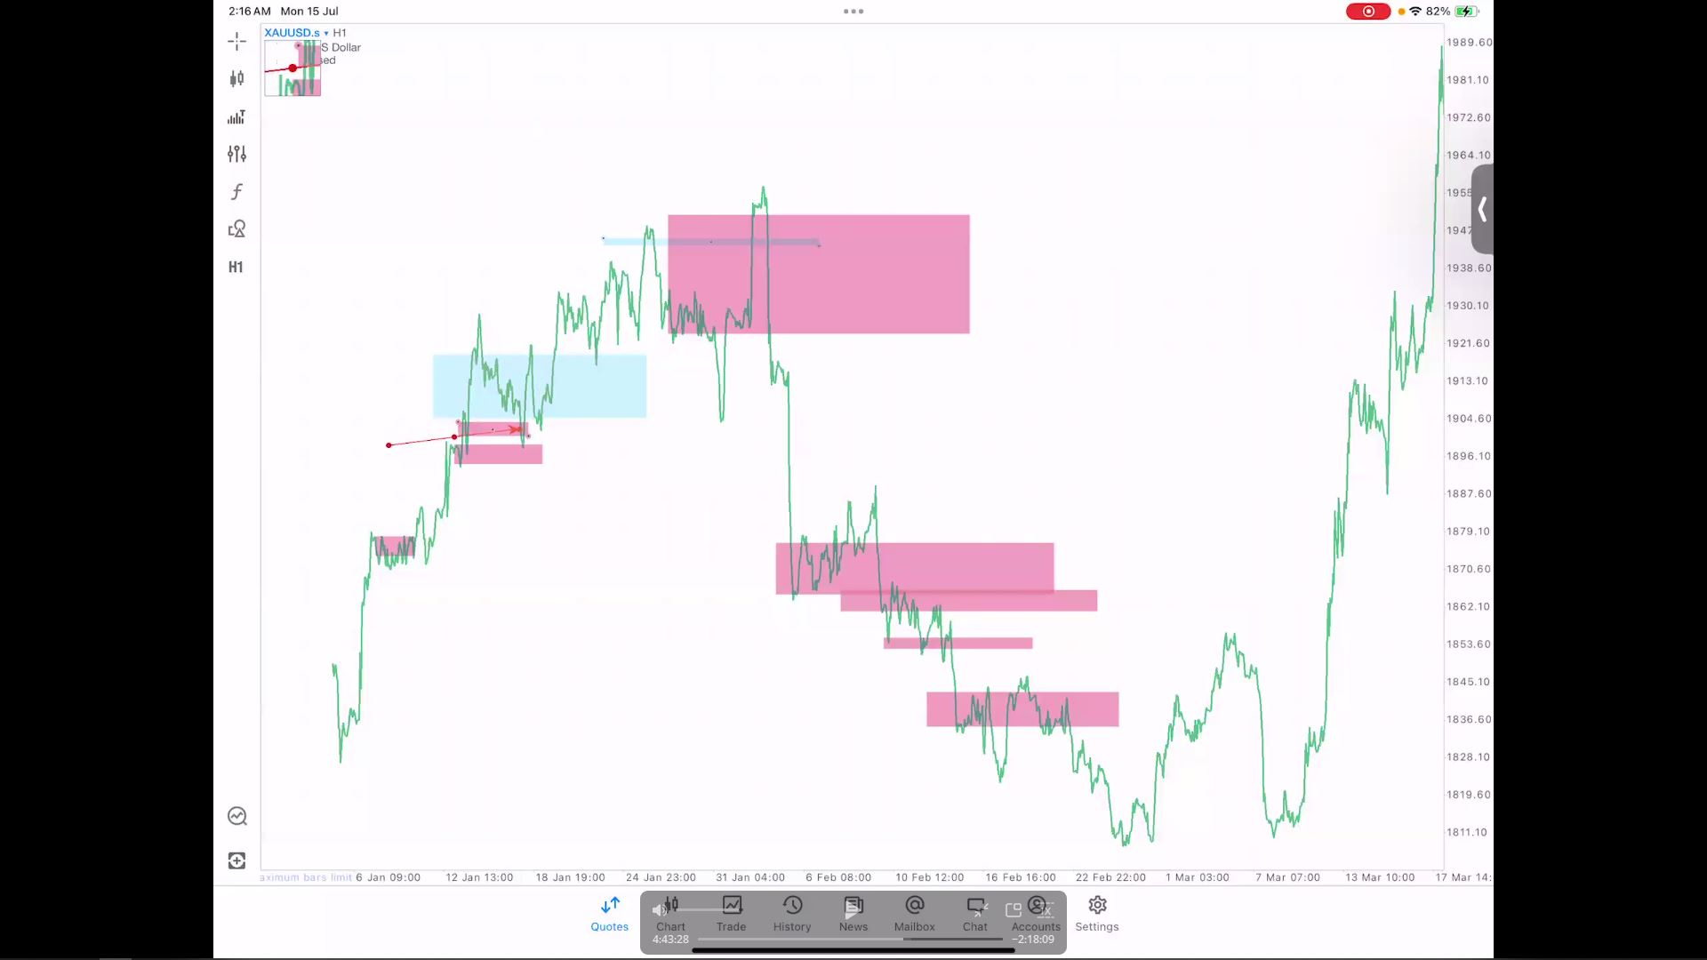

- Barrier rejection trade. When Bias, direction and sequence align FM!!!
- Entry at origin price H1 4h44m03s . entry pucuk

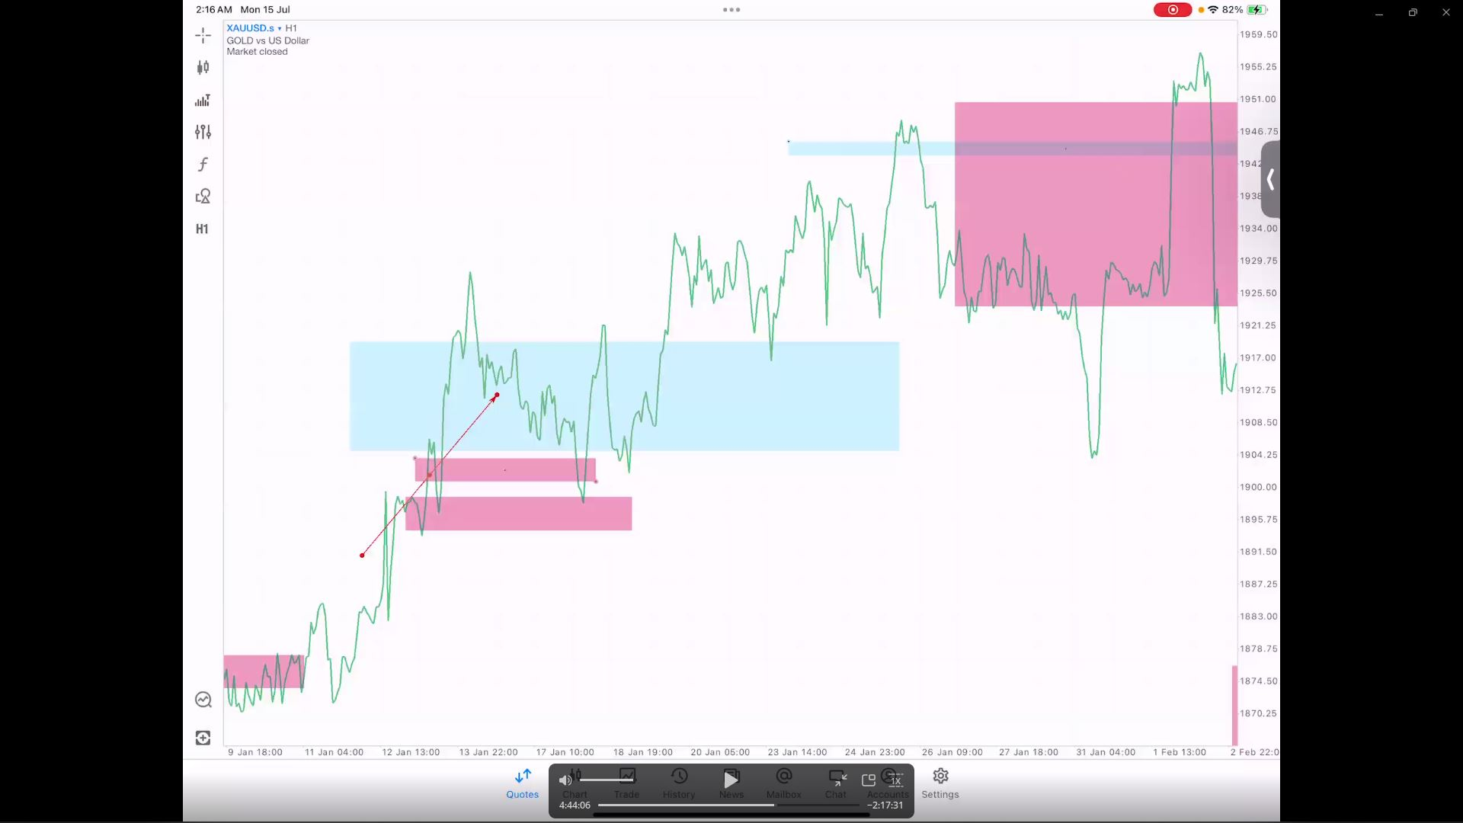

Reversal signs Phase 2 Sequence Video 4h 45m 48s
- H1 has created BO Structured. An EARLY sign of reversal. EARLY SIGNS not CONFIRMATION
- Best way to grow account is when we have a BIAS DIRECTION as a Conti Setups
- If price sideways for a long time just wait for Direction TF to make a breakout

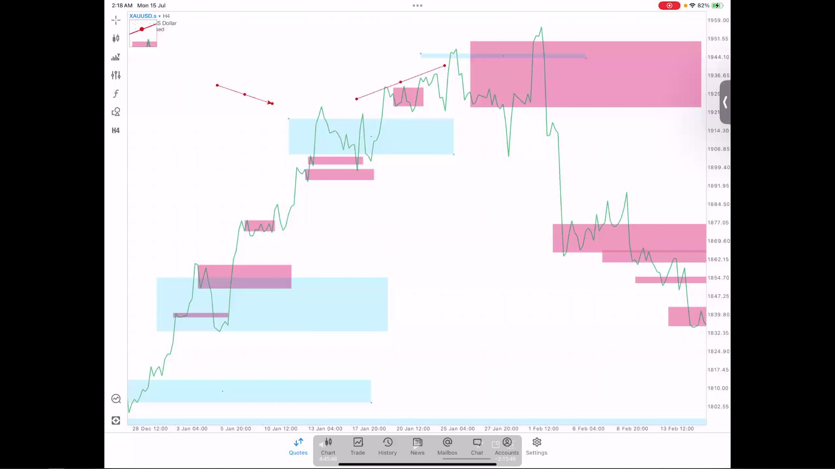
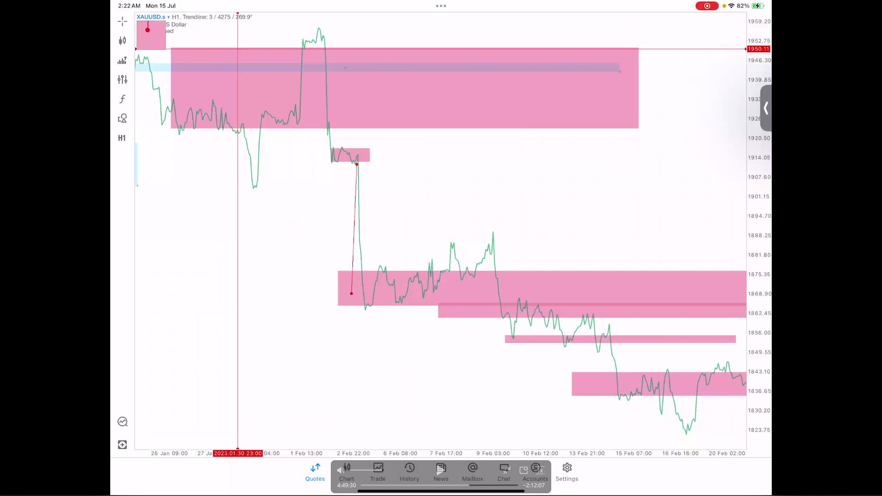

Sequence Sell Phase 2 Sequence Video 4h 51m 0s
- Follow Sequence Direction. Direction changed to sell while Bias is still a buy
- “Yang penting kita tahu tujuan BO dan mengikut direction dan sequence kita, auto kita tahu storyline”
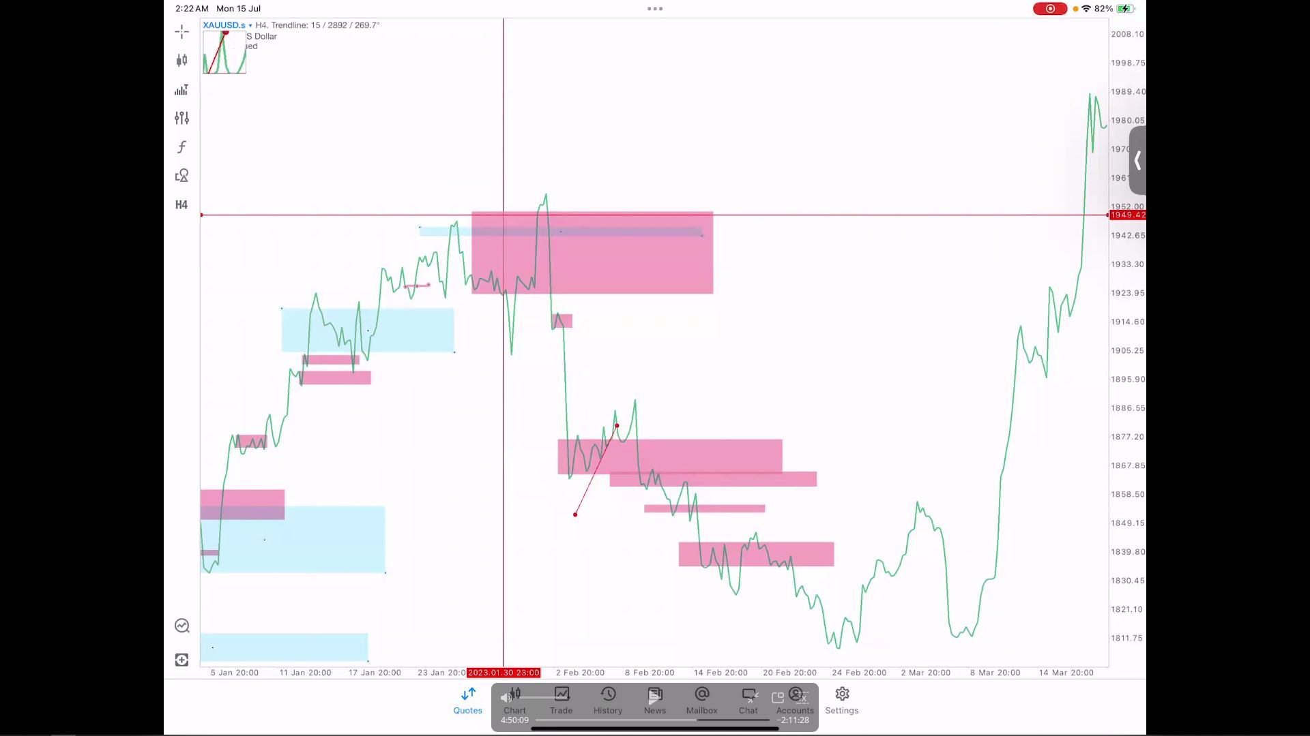
- Reversal VR which is tricky as example: Daily BO Sell, BO Buy again and BO Sell 4h56m
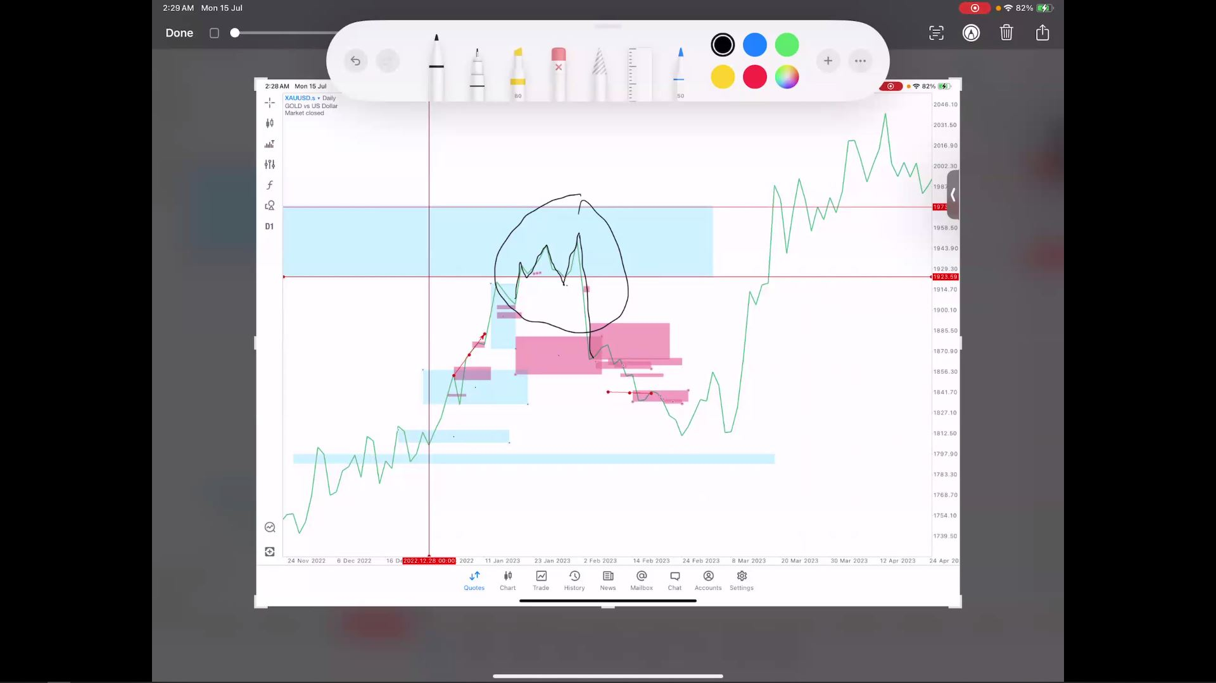

Sequence LTF Phase 2 Sequence Video 5h 04m 7s
- Follow Sequence Direction. Direction changed to different direction
- D BO, sequence D? Is H4, H4 BO, sequence H4 is H1. Check H1

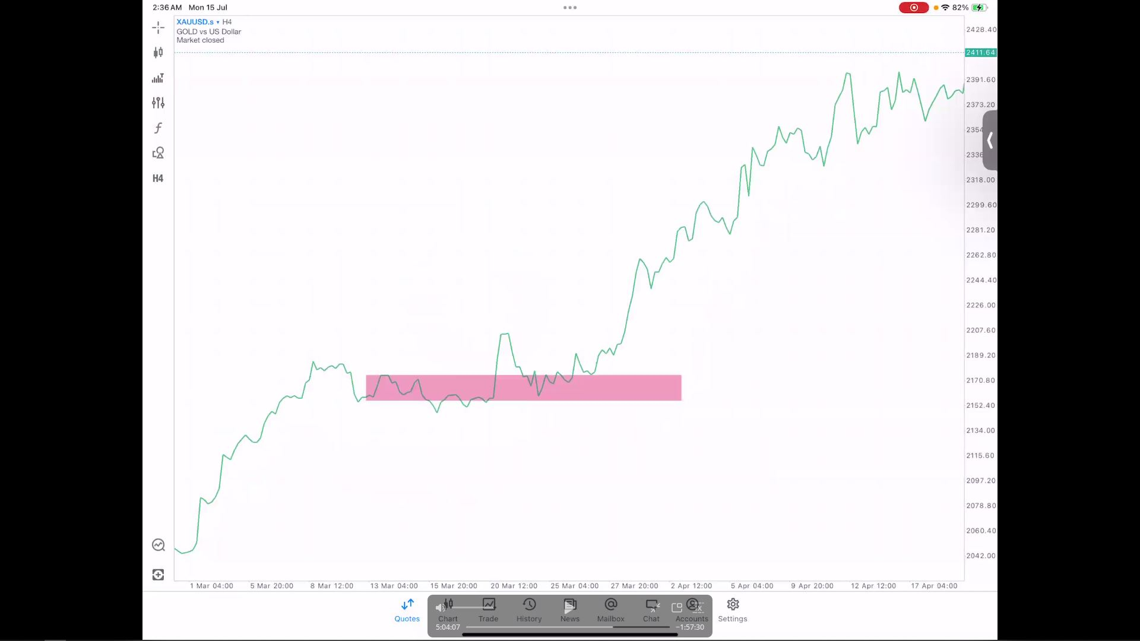

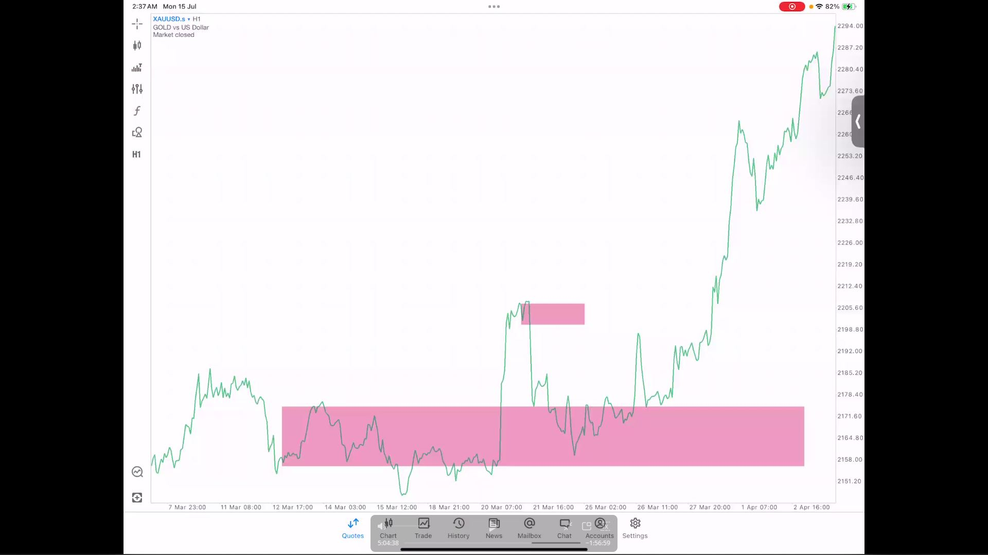

- H1 has made a sequence Sell, now look into lower TF skip m30 go straight to m15 or which ever TF that make a VR FIRST!
- Direction for that moment is temporary sell while Bias is still a BUY
- Avoiding sideways by not trading in a barrier or a point of BO. One way to enter safely is when the Control TF make a clear BO

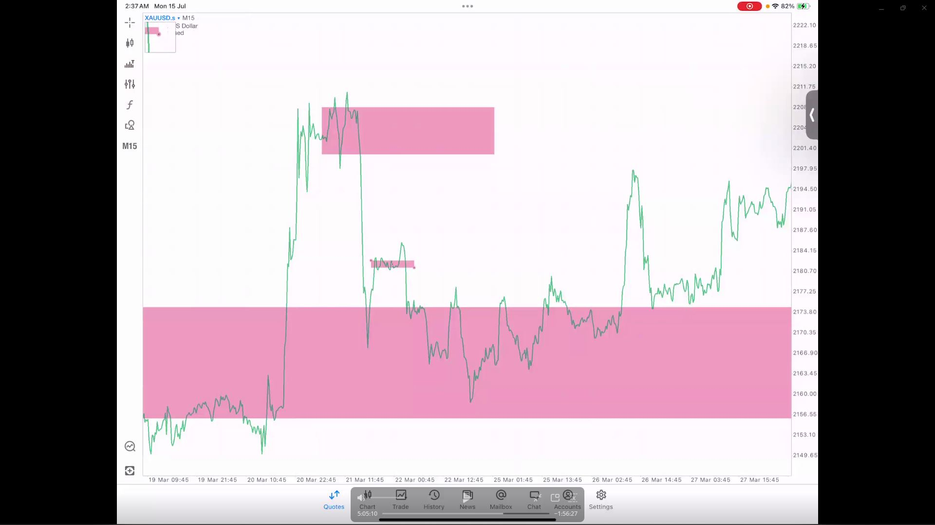
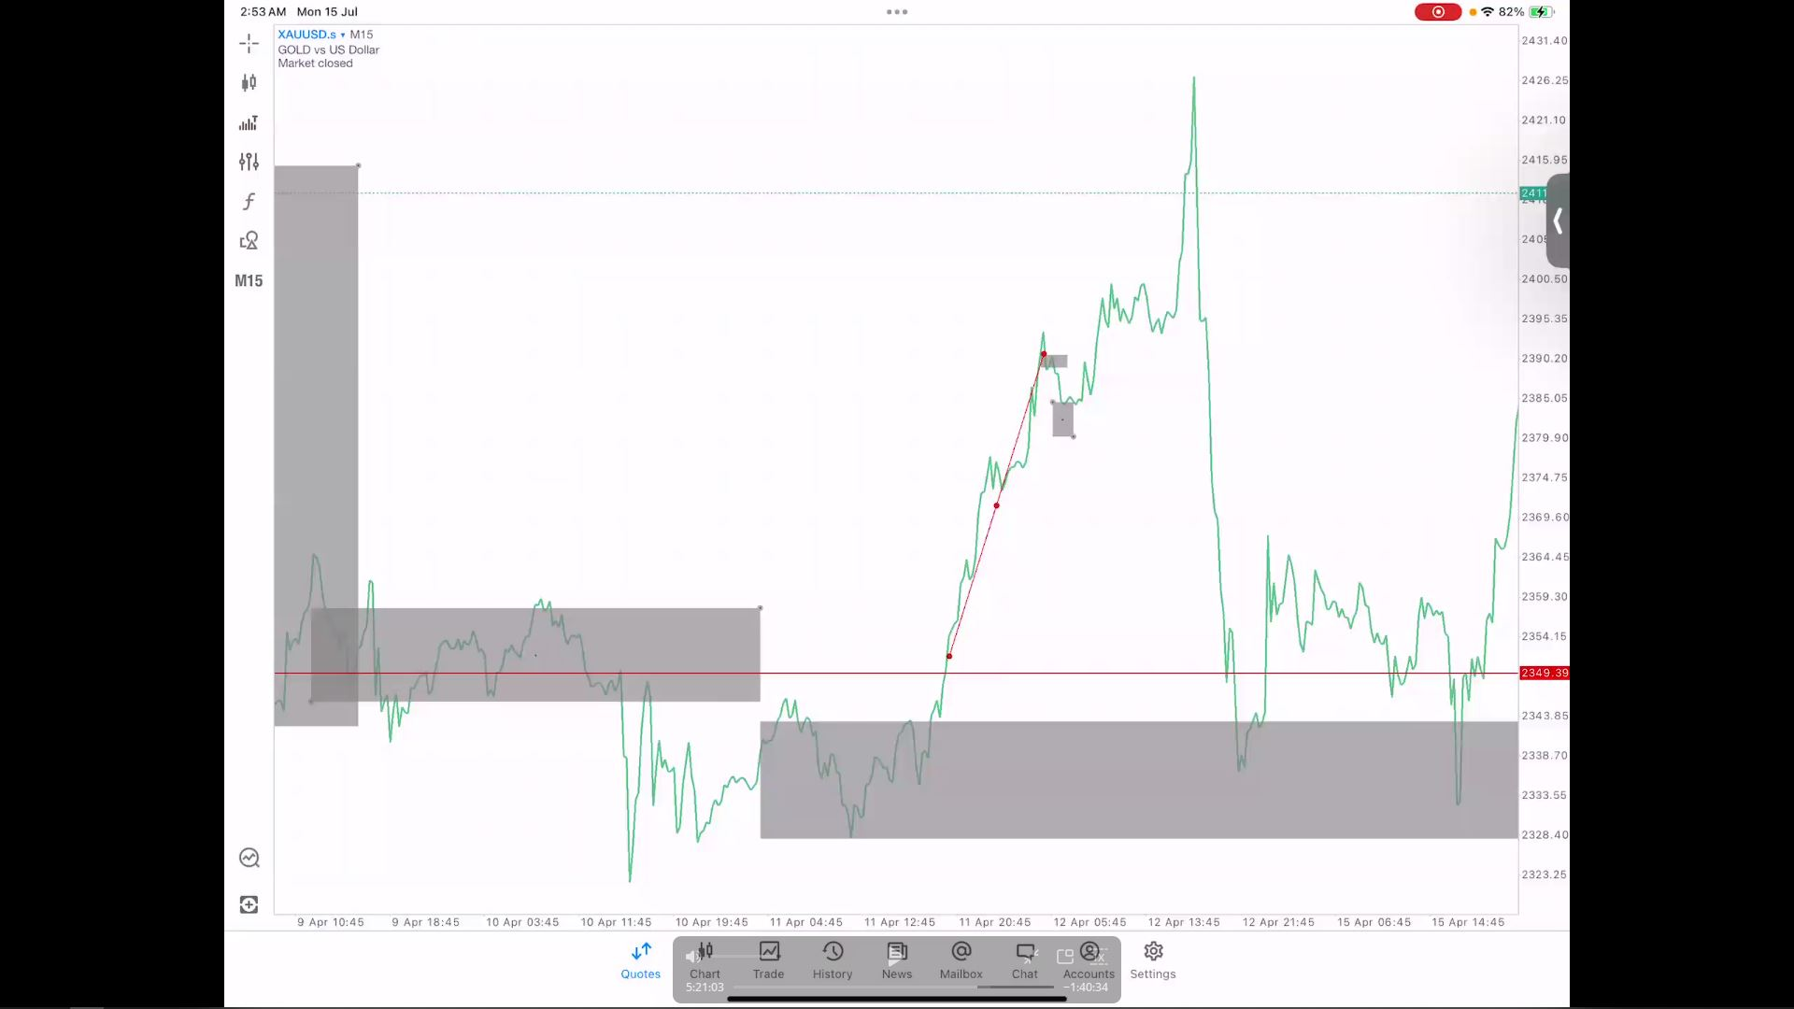

Sequence VR Phase 2 Sequence Video 5h 34m 07s
- VR that you should AVOID entry

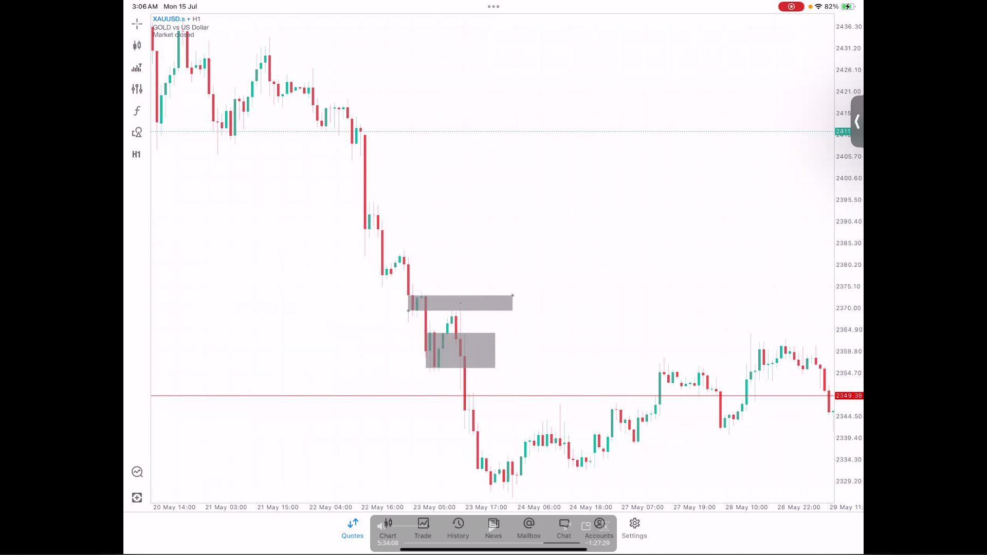
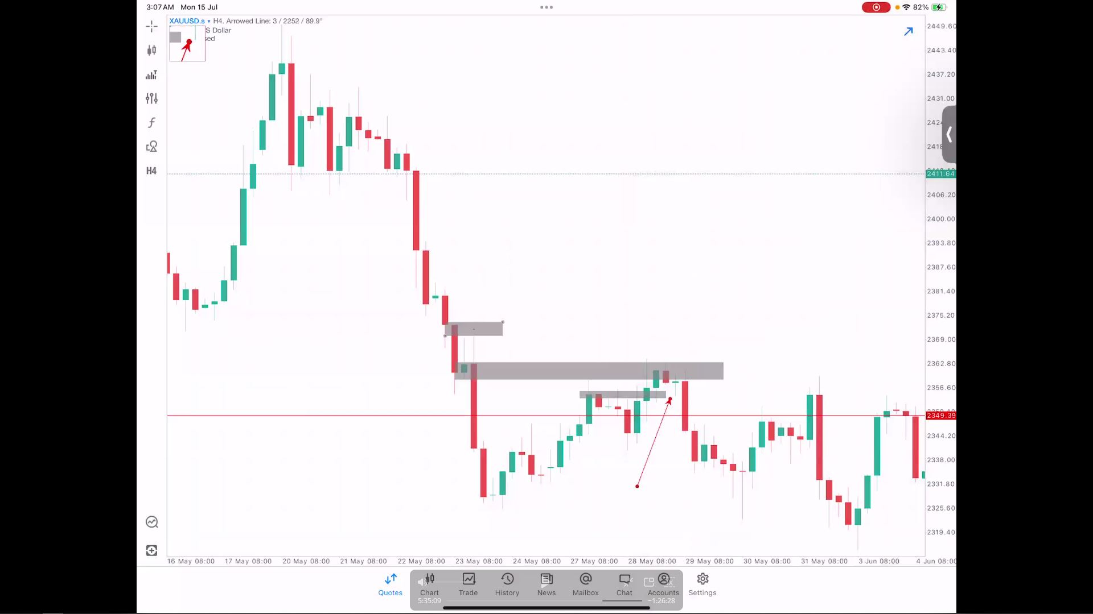

Intraday OHLC - Open High Low Close Phase 2 Sequence Video 5h 44m 22s
- Use period separator
- Every day you will look at what is going on with H1!!!!
- If H1 Sell we will follow but you need to know that H1 sell function as what? VR, CF? In this CASE, Direction for intraday is H1 as VR to H4 Buy. Who controls H4? It's H1 so we follow H1 directions.
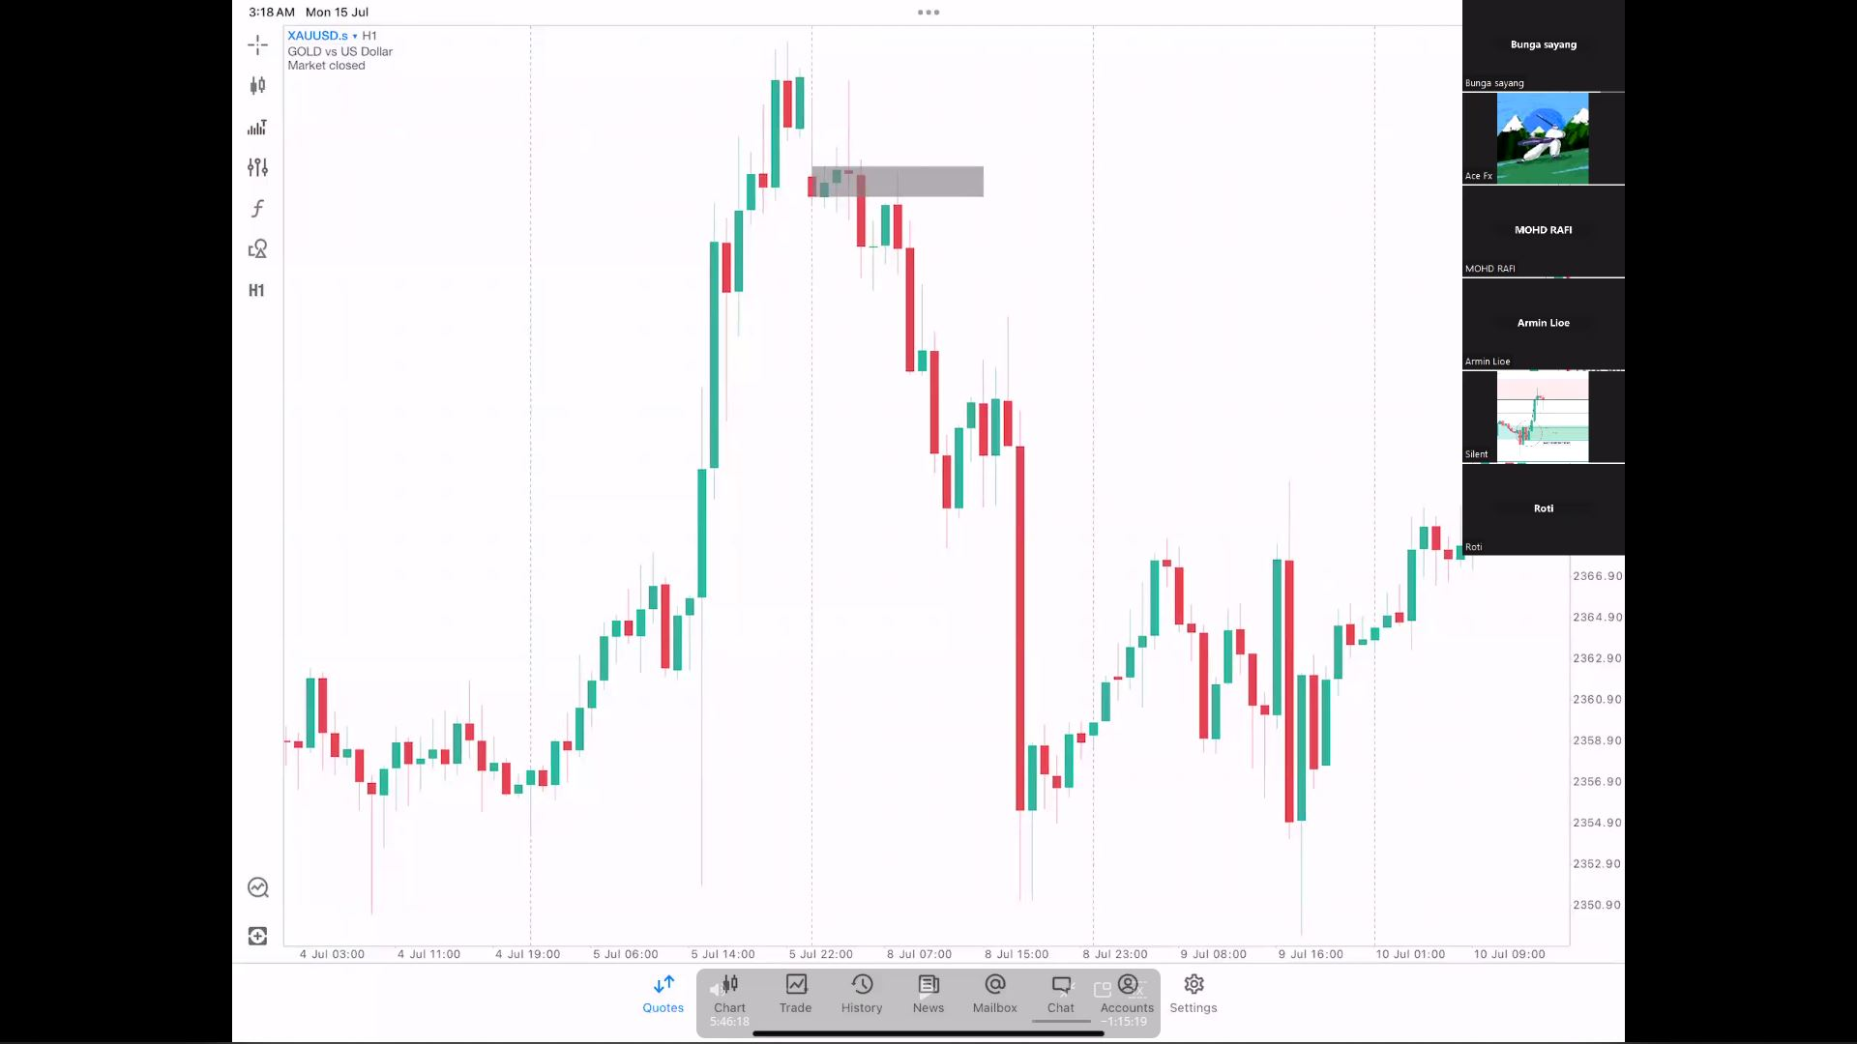
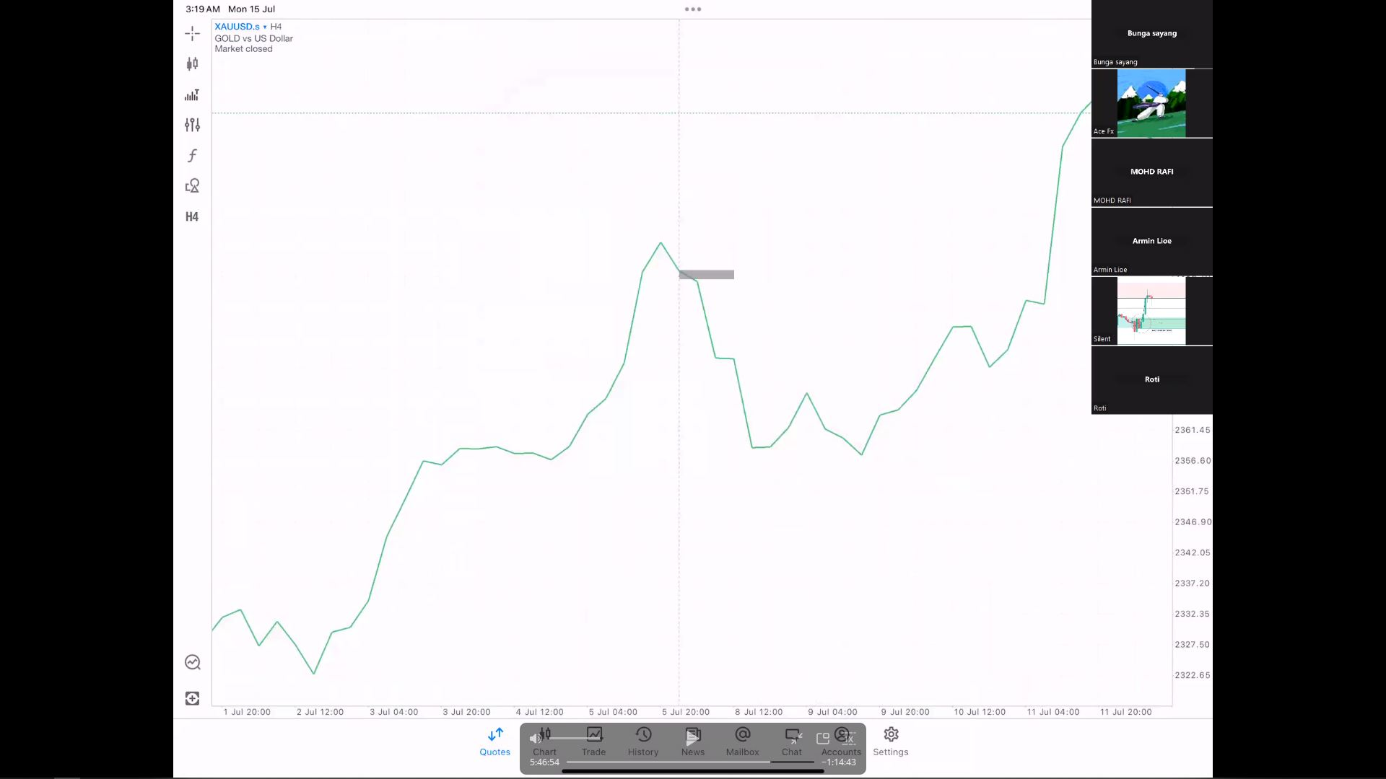
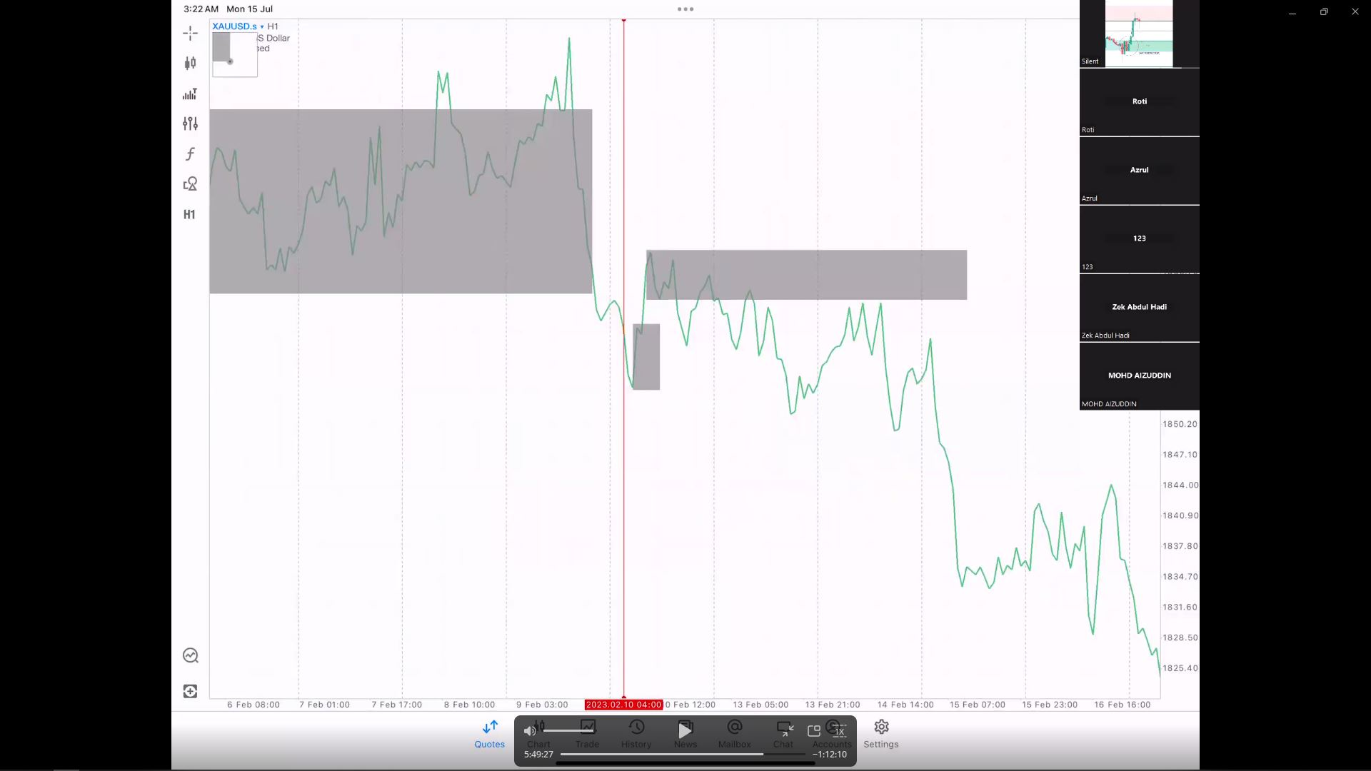
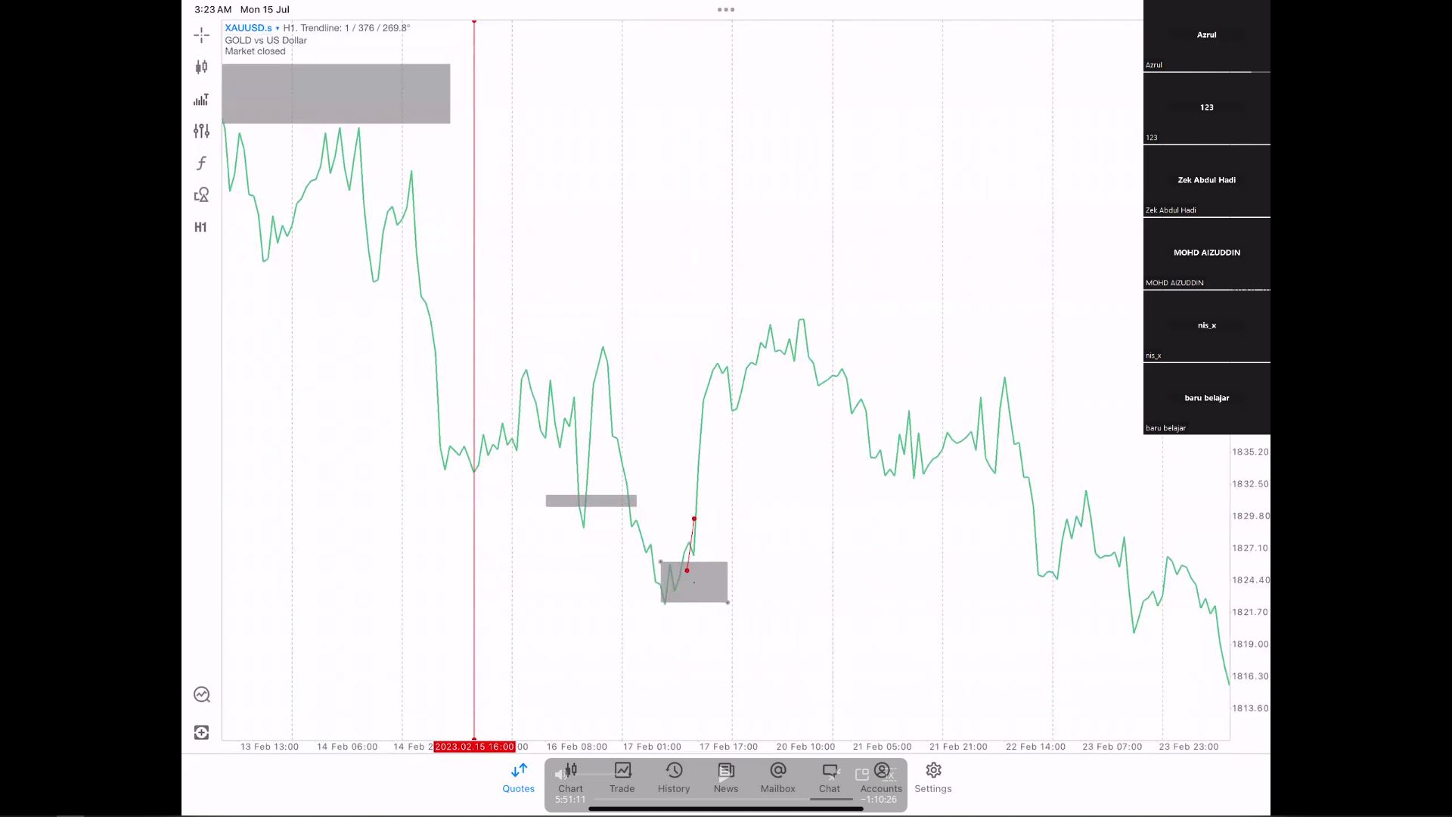
H1 BO Sell on that day as a CF to H4 Sell *Best setup
Phase 2 Sequence Video 5h 52m 52s
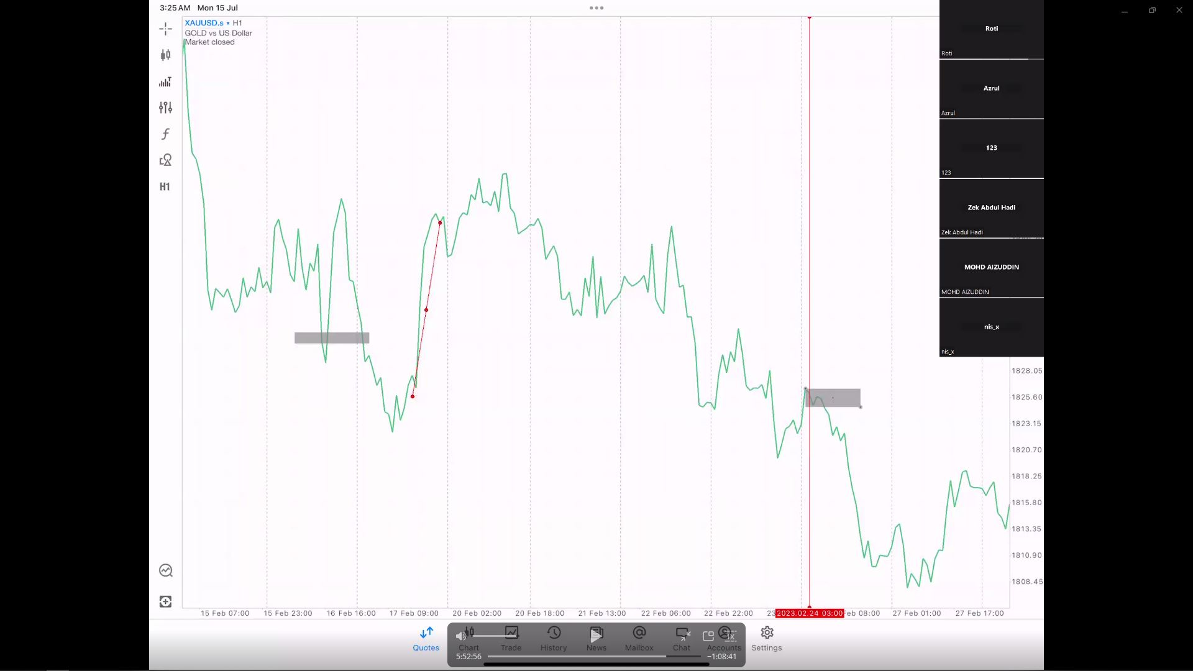
H4 Sell with H1 CF * Best set up
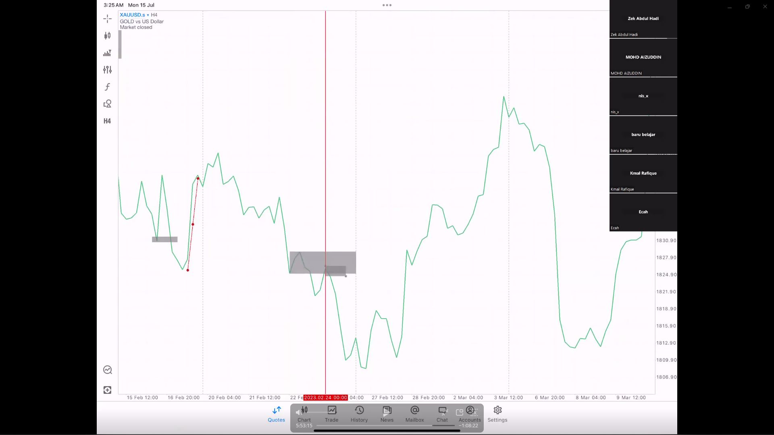

Scalping Phase 2 Sequence Video 5h 58m 00s
- Start from H4 as direction, move to M30, M15, M5
- Still follow bias and direction
- Intraday - M30 above, Scalp - M30 below, Swing H4 above.
H4 scalping Direction Sell
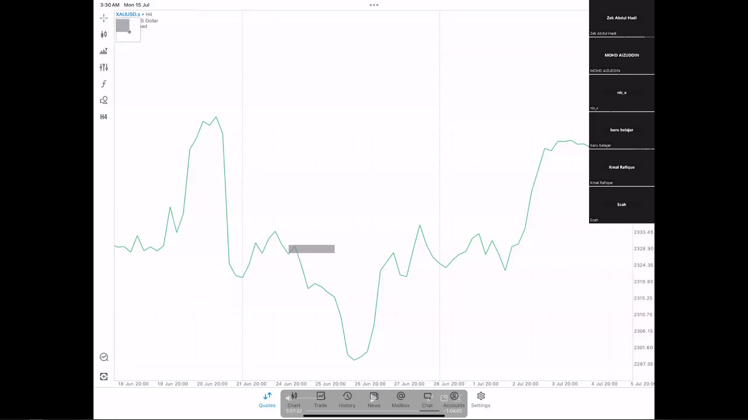
- Scalp M15 TF you MUST look one TF higher which is M30. Don't get trap in VR
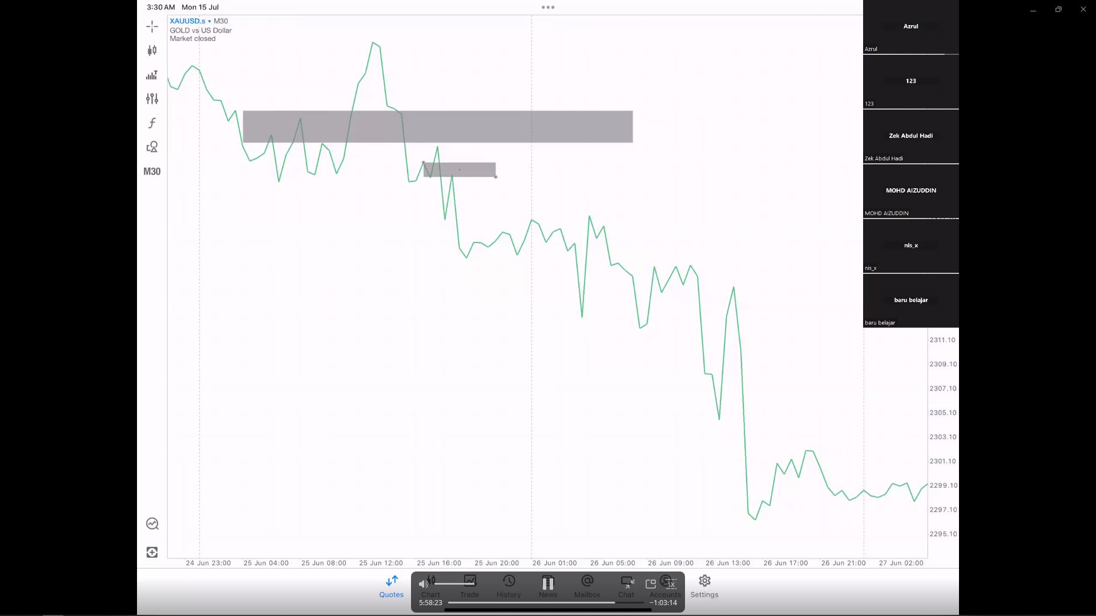

Swing Phase 2 Sequence Video 6h 17m 48s
- Start from Weekly - Daily
- Still follow bias and direction
- Counter VR when H4 made False CF
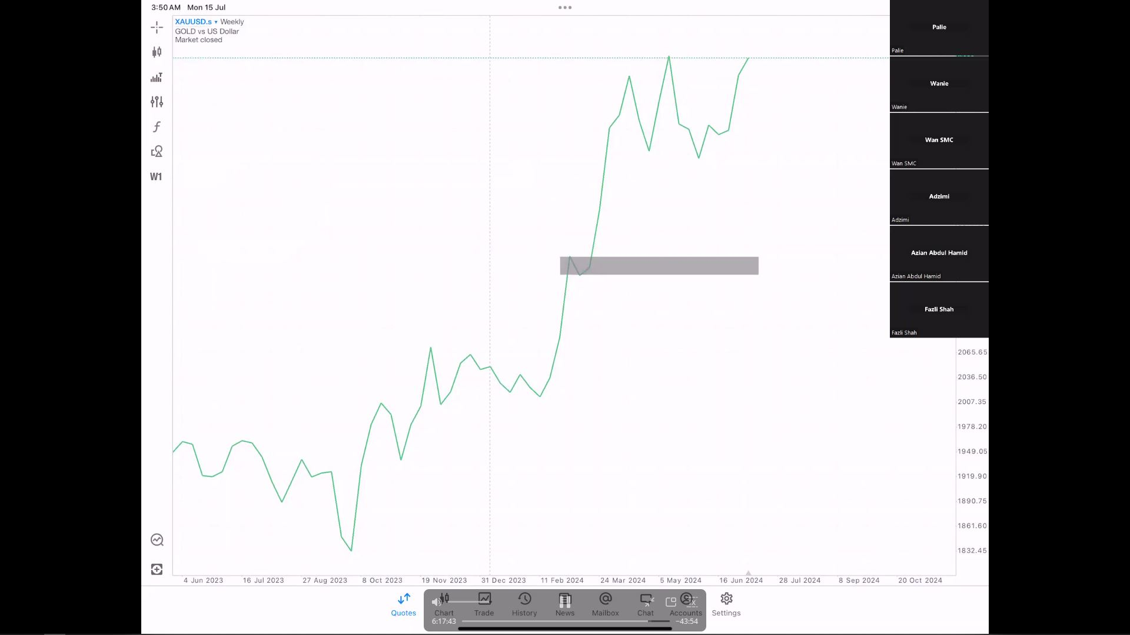
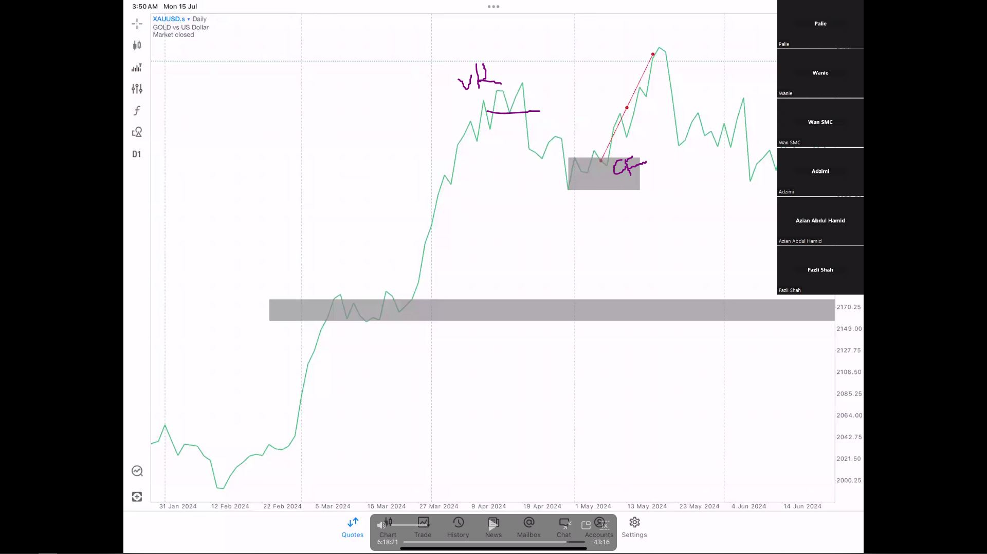

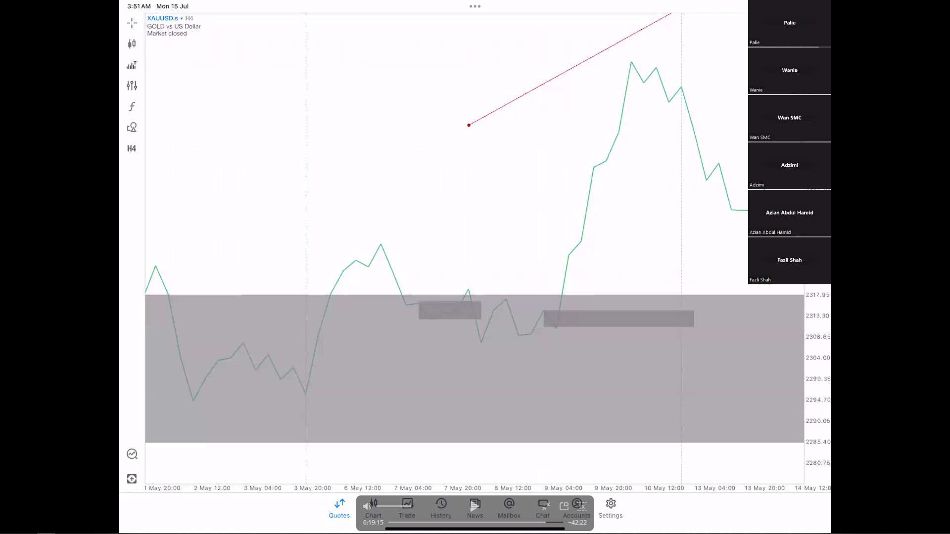
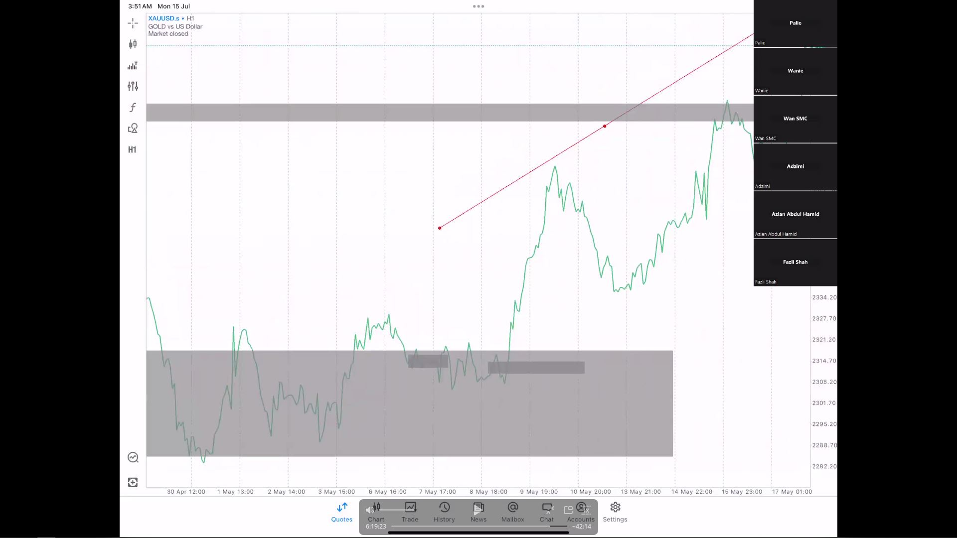

How to Back Test and do homework? Phase 2 Sequence Video 5h 37m 20s last 15 minutes
- Identify what style of a trader you want to do.
- Swing, Intraday, Scalp
- Intraday - M30 above, Scalp - M30 below, Swing H4 above.

THE END

